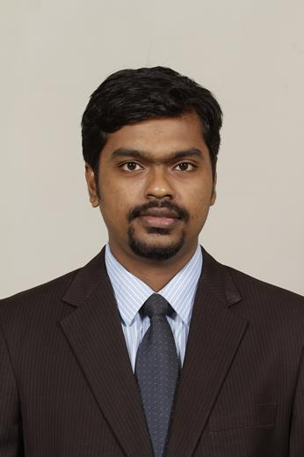
NATIONALITY:Indian DOB: 06/03/1990
EDUCATION :
MBA – Marketing&Systems , Indian Institute of Management - Lucknow (2014-16)
b.e – Computer Science, Thakur College of Engineering & Technology – Mumbai (2007-11)
Email: adik.390263@2freemail.com
PROFESSIONAL EXPERIENCE
Product Manager
Digital Strategy

- Defined a product roadmap for digital strategy across verticals in stipulated budgets
- Spearheadedimplementation of custom builtERP for optimal resource utilization & process monitoring
- Collaborated with stakeholders for requirements gathering, KPI quantification, tracking and enhancements
- Implemented a system for centralized order planning and real time logistics tracking using statistical data
- Undertook initiatives for building a robust customer database for STP thereby increasing sales by 15%
- Implemented an IT policy for employees to ensure security and reduce the costs incurred

Assistant Manager STAR India Pvt. Ltd. (May’16 –Aug’18)
Product &RevenueStrategy, Cricket Mumbai, India

- Strategized revenue generation of INR12000 Cr on Indian Premier Leagueacross a span of 5 years
- Prioritization of spots & inventory management by coordination with Marketing, Ops and Scheduling teams
- Live tracking of parameters such as TVR, Reach and Time Spent for all major clients to map deliverables
- Analyzed media properties across genres for revenue maximization and garnering new clientele

Advertisement SalesStrategy, Star English cluster
- Strategized annual plan for INR 6.2 Cr by analyzing past spends, customer value index & market trends
- Focused on nurturing relationship with top 10 clients achieving a 10% year on year growth,
- Facilitated organizational change for 100+ accounts across the FMCG, BFSI, Telecommunication categories
- Credited for having the highest target achievement of 121% in the team during the festive period of FY’18
- Achieved a market share increase of 14% in a genre which de-grew by 21% in H1 of FY’18
- Achieved a 15% reduction in campaign misses by devising better market scoping and forecasting activities

Marketing Head Royale Collections (Oct’13 –March’14)
(Gift designing and Mfg) Mumbai, India
- Diversified business by introducing new product categories & raised INR 80 lakh in sales.
- Led a team of 6 members for securing multiple clients in the pharmaceuticals sector
- Introduced JIT and ABC analysis techniques for inventory management, reducing costs by 25 %

Systems Engineer Infosys Limited (Sept’11 –July’13)
(Information Technology) Pune, Mysore, India
- Supervised the functioning of 12 applications used by more than 46,000 employees at the client end
- Engaged in grievance handling & code enhancement by coordinating with 6 cross functional teams
- Enhanced project efficiency by 40% by mentoring a new recruit over a period of 3 months
- Hands on experience with Java, RDBMS, HTML, C/C++ frameworks
INTERNSHIP AND LIVE PROJECTS
Management Trainee Verse Innovations Pvt. Ltd. (Apr’15-May’15)
(Ecommerce) Bangalore, India
- Evaluated the eBooks business of Dailyhunt, and devised business expansion techniques
- Conducted marketing mix analysis & benchmarked the application & content vis-à-vis 4 competitors
- Analyzed the business model of biggest competitor & suggested measures to bridge the gap

