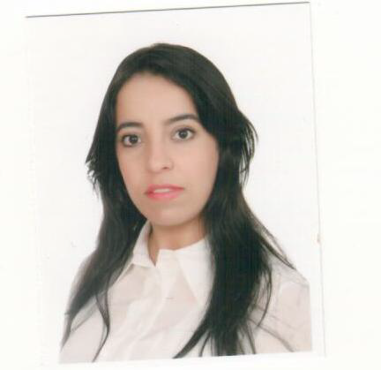
Fatima
Email: fatima.390266@2freemail.com

Personals Skills:
Polite and assertive sales professional who is motivated by being a team player with a common goal, and who has extensive experience of retail sales, with the ability and desire to meet and surpass sales targets, with drive, ambition and determination. Currently looking for a chance to progress a retail career within a fast-paced, forward-thinking and highly successful company.

SKILLS
- Team Building /Training/Supervision
- Retail Store Operations
- Team Leader
- Consistently meets sales goals
- Energetic and driven
- Goal Oriented
- Cash handling and and management
- Computer literate
- Merchandising

WORK HISTORY

Prada Emirates (Miu Miu )
Current
Sales Assistant Aug 2013 –
- Gove the highest standard of inspired customer service at all times and to act as a role model Sales consultants
- Conducting trainings of weekly and monthly update on service & productivity and Retail update
- Develop the sale by selecting appropriate range of options for the customer, providing good product knowledge ,overcoming objections and offering appropriate additional items (link selling)
- Consistently achieve individual sales targets and be aware of store sales targets
- Replenish merchandise ensuring appropriate stock levels are maintained at all times
- Identify slow moving and fast moving items. Also sock risks and give feedback to Store Manager
- Responsible in al point of procedures e.g. Global Refund customer compliance ,Till procedures (cash handling , credit authorization , exchanges) etc
- Responsible in all paperwork related to stock movement , ordering and cash management report
- Management toolkit ,through email , calls and SMS .introducing our monthly Floor set collections and inviting them for a private appointment
- Accomplishes staff results by communicating job expectations , planning monitoring , developing ,and appraising job results ,coaching , counseling ,and disciplining employees ,developing ,coordinating ,and enforcing systems , policies procedures ,and productivity standards.

Burberry Middle East
(Sales Assistant) 2011-2013

- Greeting customers entering the store in a professional welcome manner
- Assisting in processing and replenishing merchandise and monitoring stock to maintain the knowledge about the available inventory
- Maintaining the arrangement of products on the display racks and shelves to facilitate convenience for shoppers.
- Product management, including ordering, receiving, price changes, handling damaged products, and returns.
- Responsible for ensuring a consistently high standard of presentation in the store.and making sure that all available space in the store is effectively utilized.
- Focused on maximising the customers shopping experience.
- Maintaining accurate records of all pricings, sales, and activity reports.
- Providing excellent customer service.

Intercontinental Hotel Abu Dhabi 2009-2011
(Front disk officer / Banquet coordinator)

- Greet customers as soon as they walk through the door
- Provids patron with accurate wait tome estimates during busy periods
- Maintain a neat organse front of house environment
- Answerv phones and schedule reservations with largeparties

EDUCATION
- Bachelor in Literature
Moukhtar Siusi , Morocco
- Diploma for hotel
- ISDL Programme
- Languages spokien : Arabic , English , French

