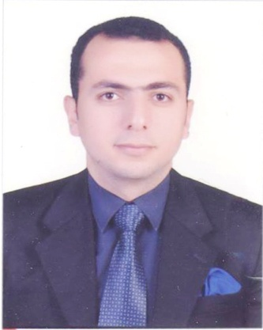
ELSHAFEI

Email: elshafei.390285@2freemail.com

Personal Details:

Nationality: Egyptian.
Gender: Male.
Marital status: Married.
Date of Birth: 19/12/1989.

Career Objective:

- To engage in challenging position in an organization that offers growth based on dedication proven ability. The ideal position would offer long term conductive to professional growth and achievement.

Education:

- 2006 - 2011 : B.Sc. in Civil Engineering
Faculty of Engineering Zagazig University/Egypt. Grade: Good.
Graduation Project: concrete structure.
Under Supervision: Prof. Mohamed Hussain. Grade: Excellent.

Skills:

Language Skills:

- Arabic – Native Language.
- English – Excellent (Speaking, Writing, Listening and Reading).

Computer Skills:

- Analysis Program: SAP 2000 – safe.
- Drawing Program: AutoCAD.
- Software Program: Microsoft Office with any version.
- MS Windows 07, vista, 2003, 2000.
- Internet applications and E-mail.

Personality Key Strength:

- Expert knowledge of applicable codes and regulations
- Excellent communication skills for interfacing with internal and external contacts.
- Excellent problem-solving skills.
- Ability to manage multiple reviews and deadlines.
- Responsive to changing demands.
- Relies on extensive experience and judgment to accomplish goals.
- Ability to evaluate new approaches, systems and design solutions.
- Detail oriented and strong analytical skills
- Extensive knowledge of standard Engineering practices, Techniques, and procedures.
- Strong organizational skills ability to plan and schedule work.
- Proficient in the use of computers for making Engineering calculations.
- Broad knowledge of precedents in the specialty area and practices of related specialties.

Employment History:

- Site Engineer.

Job description:
Civil Engineer in El_TANTAWEY for construction.

Period:
From Dec. 2011 till March 2012. (EGYPT)

- Site Engineer.

Job description:
Civil Engineer in AL-QALAZM Holding Company.

Period:
From April 2012 till April 2016. (KSA)

Projects:
- Culverts project in Turaba City
- Garden project in Turaba City
- Masjid project in Taif
- Hospitals projects in Bisha

- Consultant Engineer.

Job description:
Civil Engineer in ALQUDS Office.

Period:
From May 2016 till October 2017. (KSA)

- Site engineer .

Job description:
Site engineer for Civil Engineering works in sewage treatment plant in
King Fahd Air Base in Western Quarter .KSA, at ALQALZME Holding
Company.

Period:
From November 2017 till December 2018. (KSA)

