EHTESHAM
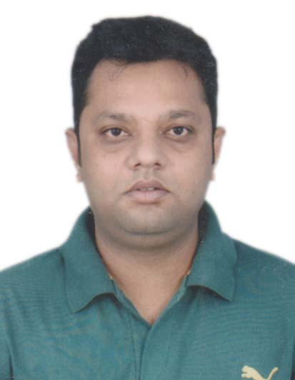
Email ID: ehtesham-390287@2freemail.com

______________________________________________________________________________________________
Profile Summary
Solutions Focused, Proactive and Industrious Professional with around 12 years of multifaceted experience in BPO/ITES industry. Broad-based background encompasses exceptional work ethic and commitment to organizational objectives within a highly competitive and rapidly changing in business environment. Proactive team-builder and tactical planner with ability to attract and secure key players in building strong and lasting business relationships. Persuasive communicator with exceptional management skills and ability to relate to people at any level of business andmanagement.
__________________________________________________________________________________________

Core Skill Areas
- CustomerManagement PerformanceManagement
- Team Management Quality Check Analysis
- CustomerService/Loyalty Customer Compliance
- Staff Training& Mentoring Training ProgramDesign
- Opportunity Identification Optimizing TAT
- Revenue Generate Ancillary function
- ProductKnowledge Engagement Program
_____________________________________________________________________
OrganizationalExperience

DELTA FACILITIES CARDS- A DIVISION OF GHANTOOTH (UAE)
Dec 2018 - Present

SALESREPRESENTATIVE

Sharjah, UAE

• Identifying and generating sales leads.

• Pitching services to new clients and maintaining good working relationship with existing and new clients.

• Cold calling prospective customers.

• Discussing promotional strategies and activities with the marketing department.

• Implementing alternative and innovative ideas for achieving new business.

• Liaise with travel partners, including airlines and hotels to manage bookings.

•Training personnel and helping team members develop their skills.

UNITEDSTRINGS TECHNOLOGIES PVT LTD
Kolkata, India Aug, 2016- Oct, 2018.

Team Lead
Under the supervision of the Senior Leader of Technical Support, the duties and responsibilities of the Technical Support Leader include:
- Leading and mentoring the Technical Support Team, performing scheduled staff reviews, communicating and adhering to new procedures, policies and goals.
- Monitoring queues and assisting with daily goals and conducting quality control to reduce errors to improve procedures.
- Establishing, recommending and implementing policies to ensure quality, timely and efficient design of customer oriented services.
- Working effectively with other teams implementing strategies to increase profitability, productivity and overall client experience.
- Auditing customer accounts to ensure accuracy of information.
- Handling escalated issues from customers.
- Participating in the Manager on Duty rotation.

LIMTEX IFOTECH PVT LTD
Kolkata, India Mar 2014-Jun 2016.

Senior Technical Support
Under general supervision, in a 24/7 in-bound call center environment, Technical Support Representatives will provide technical and network problem resolution to end-users (customers) by performing a question diagnosis while guiding users through step-by-step solutions. Solutions include, but are not limited to, diagnosing and troubleshooting basic webhosting issues, email issues, username/password issues. Support will be provided by clearly communicating technical solutions in a user-friendly, professional manner.

Job Role:
- Worked as a Technical Support Executive for Iyogi US/Canada Technical Process.
- Deliver service and support to end-users using and operating automated call distribution phone software, via remote connection or over the Internet;
- Interact with customers to provide and process information in response to inquiries, concerns, and requests about products and services;
- Gather customer’s information and determine the issue by evaluating and analyzing the symptoms;
- Diagnose and resolve technical issues, webhosting, email clients, server errors and more;
- Research required information using available resources;
- Follow standard processes and procedures;
- Identify and escalate priority issues per Client specifications;
- Redirect problems to appropriate resource;
- Offer alternative solutions where appropriate with the objective of retaining customers’ and clients’ business;
- Organize ideas and communicate oral messages appropriate to listeners and situations;
- Follow up and make scheduled call backs to customers where necessary
- Stay current with system information, changes and updates.

WIPRO LTD-(BPO)
Kolkata, India Sep, 2009-Dec, 2013.

Senior Associate
Wipro is the leading organization in the BPO industry. Wipro is the premium leader in the BPO sector who takes the strategic step for companies looking to improve service levels, reduce costs, streamline processes, improve process efficiencies, and gain access to best-in-class processes without investing in requisite technology and skills.

Job Role:
- Worked as a technical support associate for US/Canada Voice Tech Support process with regard to HP brand.
- Installation & configuration of a company’s computer software operating systems and applications.
- Maintenance and monitoring of computer networks and systems.
- Analysis of call logs in order to discover any underlying issues or trends.
- Responding to call-outs in a timely fashion.
- Responsible for solving all kinds of software issues following relevant troubleshooting steps relating to HP products, carrying out team effort to ensure customer satisfaction.
- Authorized to sell hp and non hp products as per the customer’s requirement.

Tenure | Organization worked with | Designation
2008 – 2009 | Aircomm Telecommunication Pvt Ltd | Senior Executive-Operations
2007– 2008 | First Source solutions Pvt. Ltd | Relationship Manager
2006 – 2007 | Aegis Bpo Services Ltd | Customer Care Officer

Academic Credentials
Bachelor of Commerce
Umesh Chandra College/Calcutta University, 2005.

I.S.C. (Higher Secondary)
S.G.J Public School, 2001.

I.C.S.E.
Albany Hall Public School, 1999.

IT Skills
- Well versed with Ms-Office (Excel, Word, Power point etc.,)

Personal Dossier
Dateof Birth : 15thOct.
Religion :Islam
Language Known :English, Hindi, Urdu, Bengali and Arabic with limited working Proficiency.

