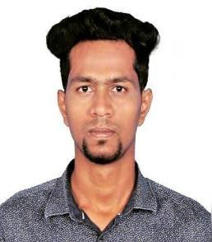

SAMED
Email: samed.390316@2freemail.com

2-Years’ Experience

I am a Business Administration graduate had an experience of 2 Years in an Audit Firm and played a role as a “Accounts & Finance Manager” under a Leading Chartered Accountant, Firm "YSIL & CO" at. Chennai, India

Enriched with enormous knowledge in Accounting & Taxation in a journey of 2 years gained me confident and strength.

Working Experience Details

Firm Name: Ysil & Co., Chartered Accountant
Duration: August 2016 – October 2018

Areas of Expertise:

Computation of total income of Individuals, Firms & Companies for the purpose of Tax Planning, Tax Advise etc.,
Preparation and filing of the Income Tax, VAT & SERVICE TAX returns.

Preparation of Monthly returns and filing of GST.

Preparation of Accounts, Financial Statements as per the applicable statutory frameworks for Individuals, Firms & Companies.
Well versed in Accounting, Book-Keeping, Reconciliations etc.,

Involved in the process of Auditing and its related matters.

Thorough knowledge about Registrar of Companies (ROC) compliances and filings

Assisting in Various Business and License Registrations.

Experienced in Accounts Finalizations.

Co-ordinate with Government Official's on various matters pertaining to taxation and registration issues.
Preparation of MIS Report on Accounting & Auditing Matters.

Educational Qualifications:

Bachelor of Business Administration from Jamal Mohamed College of Arts and Science- Trichy, 2016 with Aggregate of 6. 5 CGPA.

Higher Secondary Certificate from Government Higher Secondary School – CuddaloreDist, 2013 with 52%.

SSLC – State Board from Government Higher Secondary School – Cuddalore Dist, 2011 with 56%.

Key Strength:

Eager to learn.
Ability to handle problems effectively.
Highly Optimistic.
Exercises good Managing Skills and has good Communication skills.
Socially and Ethically responsible

Technical Skills:

- Proficiency in Working with various Operating System.

- MS-Office.

- Tally.

- Learned about Computer Aided Audit Techniques.

Personal Details

Date of Birth | : | 18.12.1993
Sex | : | Male
Nationality | : | Indian.
Marital Status | : | Single
Languages known | : | English and Tamil

