Curriculum Vitae

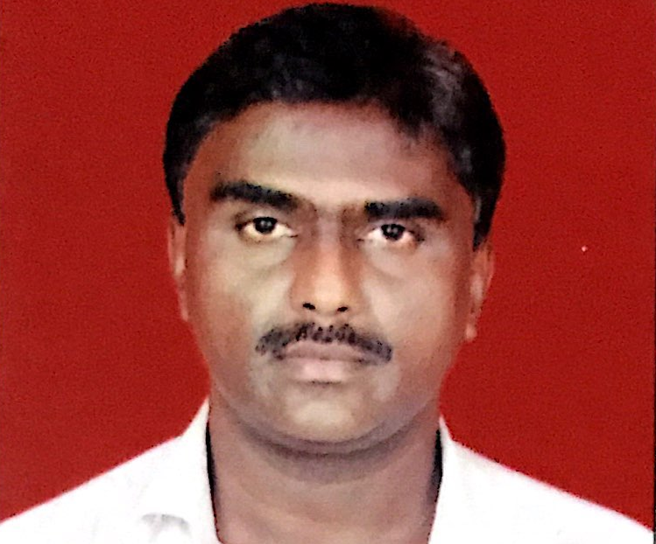

RAKESH

Email: rakesh.390325@2freemail.com

PERSONAL SUMMARY:
A result driven committed and articulate sales oriented representative with excellent communication skills. Having skills to plan & manage territory.
Maintain and developing existing and new customers .Possessing a good team spirit.
Now looking forward to make a significant contribution in an ambitious and exciting company that offers a genuine opportunity for progression

- OBJECTIVE: By Concentrated efforts will aspire to head the sales team.
- WORK EXPERIENCE :
- Experience in Pharma Sales & Marketing in Mumbai-India

Skylines Tax Consultancy - Dubai
VAT Processing and Accounts OCT 2017 – NOV 2018
Duties:
- Generating Sales from SME’s and Corporate companies .
- Direct selling of Financial Products and VAT software packages
- Following up with customers after sales ,solving queries and attending complains.
- Following up for payments for renewal of contracts.
- Preparing weekly, monthly, quarterly projections vs targets.
- Represent company at conferences, meetings and industry events.
- Ensure that proper follow up procedures are managed
- Ensuring the overall smooth running of the Company’s internal administration and its cost-effectiveness
- Responsible for complete VAT CYCLE.

- Previous Companies in India :

- S.H.Pitkar Orthotools Pvt Ltd.
- Duration : Oct 2011 to Sept 2017
- Maxillofacial Dental implants and Orthopedic Trauma Implants
- Designation : Regional Sales Manager

- Uniprogen Biotech Pvt Ltd.
- Duration : Dec 2007 to Sept 2011
- Designation : Regional Sales Manager

- VHB Life science Pvt Ltd.
- Duration : Oct 2005 to Nov 2007
- Designation: Area Sales Manager

- ALKEM Laboratories Ltd (Div : Bergen Healthcare)
- Duration : Jan 1999 to Oct 2009
- Designation : “Area Sales Manager”(From April 2001)
- “Medical Representative” From Dec 1999 To March 2001)
- Zydus Cadila Healthcare Pvt Ltd.
- Duration : Oct 1996 to Jan 1999
    - Designation : Medical Representative.

- Duties:
- To meet the Dr’s and promote products to generate Priscriptions and meeting purchase managers of Hospitals and Retail stores to procure Orders.
- Quoting Tenders at Govt Institutions like Railway Hosp,Army Hosp,JNPT,BPT etc.
- Making availability of products at Medical stores catering near to the Dr’s.
- Stockiest(Dealer) Handling with Inventory control system and collecting payments.
- Working as Regional sales manager of the sales team to develop both new and existing products.
- Liaising with Customers (Doctors) & the Dealer network.
- Writing accurate & informative sales reports and documentation.
- Identifying the customer needs.
- Dealing with a diverse range of Dr’s in private and the public hospitals.
- Evaluating competitor activities and developing appropriate strategies.
- Attending trade shows, conferences and exhibitions when required.
- As a Manager handling team, providing training, Motivating the team
- And get Best work done from the team.

- Key Skills & Competencies :
- Have a professional style of Good communication skills & ability to build rapport with prospective customers.
- Able to sell to large and small hospitals, Nursing Homes and clinics.
- Proven experience in Launching new products.
- Conducting CME's (Continuous Education Programme) for Dr's
- Presentation of Products with Unique selling points.

- Personal Skills :
- Building relationships
- Smart appearance & presentable
- Highly Motivated and a Good Motivator
- Social skills
- IT Skills
- Operating Internet , Email
- Ms-office, Ms-excel, Ms-word

- SUMMARY OF QUALIFICATIONS

- Education | - University | - Year of passing | - Class Obtained
- T.Y. B.Sc | - Mumbai | - 1995 | - Second Class
- H.S.C | - Mumbai | - 1992 | - Second Class
- S.S.C. | - Mumbai | - 1990 | - First Class

- Date Of Birth : 21st November 1974
- Marital Status : Married
- Languages Known : English, Hindi ,Telugu and Marathi.
- Extra Curricular Activities : Playing cricket and Chess .
- Belief : “ Nothing is Impossible, Unless & Until we try “.
- Visa Status :Visit Visa

