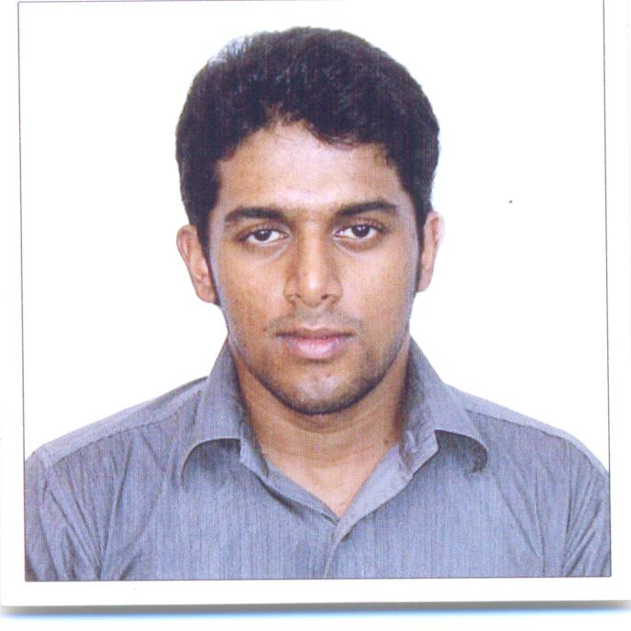
Nitin

Email: nithin.390332@2freemail.com

Professional  Profile | - Sales Coordinator with over 8 years of experience flawless preparation of presentation, preparing facility reports and maintaining the utmost confidentiality  - Adept at interdepartmental coordination and communication  - Possess comprehensive knowledge of Microsoft Word, Excel, and Outlook  - Helped with establishing new branches and up keeping of display  - Have Sales experience of 10 + year in Retail, Real Estate and Merchandising in total
Professional Experience | Showroom Coordinator,  Stock controller  - SAP system Automotive  - Customer Service Support  - Managing Invoicing, Sales Return Monitoring key activities and issuing LPO to vendors  - Pre delivery inspection of cars  - Generate business analysis report  - Spearheading SAP related activities like compiling & capturing all transactions pertaining to control of documents required by business. Eg Invoicing, Sales return, Stock Transfer, Monitoring key activities and issuing LPO to the vendors.  - Acting as a link between various users in branch and external service providers such as workshop, drivers, external regulatory agencies to ensure seamless delivery to customer.  - Monitoring the stock units required for the showroom and ensuring all display units are as per required standard.  - Performed analysis using financial & inventory data on Microsoft Excel that is used to assist in making business decisions or advising the director where the firm is heading.  - Foster customer service/Sales for Business requirement
SANTHIMADOM BUILDERS AND DEVELOPERS, Guruvayoor, India
Senior Sales Executives, February 2009 - June 2010
- Setting up of Promotional campaign in different cities.
- Prepare and maintain records and case files, including documentation such as clients' personal
- Conducting and taking active participation in Exhibition and Promotions of our Product.
- Manage and meet marketing expense budgets

TRAVEL VALUE SHOP, DAA, IRELAND
Sales Executive, May 2008 - October 2008
- Ensuring attractive merchandise display & overall store layout. Ensuring interior and exterior of store is maintained as per company standard.
- Help in organizing and implementing sales promotional and any marketing activities in conjunction with the Operations and ensuring that the setup is in line with operational policies and successful.
- Maintain relationship with target customers, customer service, ensuring high rate of return on investment, sales support and sales.
- Advising on forthcoming products developments and discussing special promotions with management

MARK AND SPENCERS, DUBLIN, IRELAND
Sales Executive, May 2007 - May 2008
- Advising on forthcoming products developments and discussing special promotions with management
- Help in organizing and implementing sales promotional and any marketing activities in conjunction with the Operations and ensuring that the setup is in line with operational policies and successful.
- Maintain relationship with target customers, customer service, ensuring high rate of return on investment, sales support and sales.
- Ensuring attractive merchandise display & overall store layout. Ensuring interior and exterior of store is maintained as per company standard.
- Help in organizing and implementing sales promotional and any marketing activities in conjunction with the Operations and ensuring that the setup is in line with operational policies and successful.

Education | DUBLIN BUSINESS SCHOOL, DUBLIN, IRELAND  International MBA(Services Marketing) February 2006 – June 2008  - Did a project for M&S, Dundrum, Employee perception of Quality of work life in Retail Sector(2008)
S.S.M COLLEGE OF ENGINEERING, NAMAKKAL, INDIA
B.Sc.(Information Technology) May 2002 – June 2005

- Created Messenger Service between Customer and Bajaj Auto for my project in 2005 using VB.net and C++.
- Went to Indian Institute of Science, Bangalore for Campus Tour
Additional Skills | - Have working knowledge of Java, Sap, Android, Microsoft Office , Windows and Apple Macintosh  - Have certification in Computer Science Engineering from KHDA Dubai
Awards and Honors | - Won 1st place Community Reporter for Gulf News for the month of April 2014.  - Won 2nd place Community Reporter for Gulf News for the month of October 2014.  - Got featured every month in Community Reporter for Gulf News from the month of January to June 2015.  - My tour photo for Salalah, Kasab, Turkey and Muscut was published in Gulf News.  - Got interviewed on Mango FM, India for giving my Inputs for Santhimadom Builders and developers.  - Represented www.indianautosblog.com website for the Dubai Motor Show 2013.  - Numerous photos of vehicles got published in www.indianautosblog.com.  - Won letter of the week for Wheels Magazine December 2013.  - Won 2nd place Community Reporter for Gulf News for the month of May 2016.  - Won 3nd place Community Reporter for Gulf News for the month of June 2016

