CURRICULAM VITAE
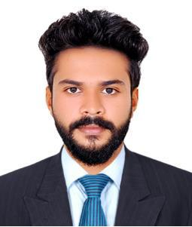

ASHICH.

Assistant HSE officer

Email: asich.390338@2freemail.com

VISA : Visit VISA

OBJECTIVE

To obtain a position that will enable me to use my strong organization skills and ability to work well with people.

EXPERIENCE

Had as an Assistant HSE in CCCL ltd from March 2018 to February 2019.

ROLES

- Ensuring good communication between employer and employee are maintained.

- Being a personal example of all time by using the correct personal protective equipment/clothing and following all safety requirements and procedures.

- Bringing company related health and safety matters to the attention of the Board Of Directors at regular intervals.

- Ensuring adequate means of distributing and communicating health, safety and welfare information obtained for the HSE, safety organizations and trade associations regarding new technique of accident prevention, new legislation requirements and code of practice etc.

- Ensuring that an adequate programme of training for health and safety is established and that the safety culture is encouraged amongst employees.

- Making proper arrangements for staking and storing of hazardous building materials.

- Conducting regular workplace safety inspection.

- Taking appropriate measures to prevent environmental incidences and maximize recycle to reduce waste, discharges and emission.

- Promoting tree plantation, green surroundings and protection of biodiversity at our location to be in harmony with nature.

EDUCATIONAL QUALIFICATION

NAME OF COURSE | UNIVERSITY | MONTH AND YEAR OF
 |  | PASSING
BCOM | MKU, MADURAI | Waiting for result
PLUS TWO | UNIVERSITY OF KERALA | MARCH 2O14
Higher secondary
SSLC | UNIVERSITY OF KERALA | MARCH 2012

CERTIFICATION COURSES

NAME OF COURSE | COURSE PROVIDER | MONTH AND YEAR OF
 |  | PASSING
The National Examination
Board in Occupational | PETROTECH SAFETY | MAY 2018
Safety and Health | SOLUTIONS
(NEBOSH)
Master log certificate
no:004012113/987828
INSTITUTION OF
OCCUPATIONAL SAFETY | HSEI | OCTOBER 2018
AND HEALTH | APPROVED CENTRE:2099
(IOSH)

TECHNICAL SKILLS

- Basic Computer Awareness

- Word

- Excel

- Video content development

PERSONAL DETAILS

SEX | : | Male
DATE OF BIRTH | : | 11-11-1995
NATIONALITY | : | Indian
MARITAL STATUS | : | Single
LANGUAGES KNOWN | : | English, Hindi, Malayalam & Tamil

