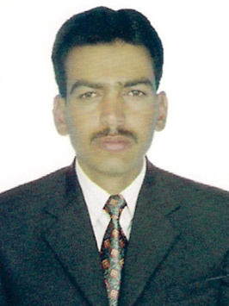
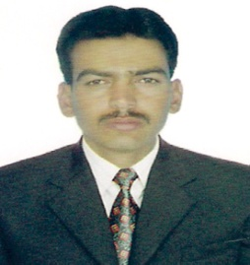

Shahab
CURRICULUM
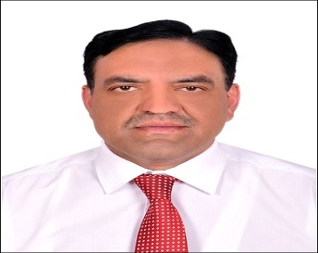
VITAE
Nationality: Pakistani
Visa Status: Tourist Visa
Email: shahab.390344@2freemail.com

APPROVALS
OSHAD/QUDORAT PRACTITIONER (Safety Practitioner
Course passes Registration in process)
Professional Objectives

A qualified, result oriented, dedicated and skilled Occupational Health Safety & Environment professional with 12 years UAE of construction, Industrial and Facility experience. Expert at inspecting and evaluating workplace hazards, Recommending and implementing of safe workplace policies and procedures. Outstanding interpersonal presentation and training skills with proven ability to interact confidently and effectively as an individual or as a team member.

Academic Qualification

- HSC Pre-Engineering (Tariq Bin Zaid Collage Karachi Board Of Intermediate Examination Karachi).
- Bachelor Economics ( Alama Iqbal University Islamabad)

Professional Safety courses

- NEBOSH International General Certificate from NEBOSH, United Kingdom.
- IOSH Managing Safely.
- OHSAS 18001-2007
- ISO 14001-2007.
- Basic First Aid.
- Accident Incident Investigation.
- FIRE Marshal Training.

Professional Training

- STARRT ( Safety Task Analysis Risk Reduction Talk)
- Electrical Safety
- Permit to Work System
- Hydro Testing
- Deep Excavation
- H₂S
- Work At Height
- Isolation/LOTO
- Access Control
- Traffic Management/ Road Safety
- Waste Management
- Safe Mechanical Lifting
- Chemical Handling

Working Experience
The detail of my 12 Years UAE’ experience in health and safety organizations in the field of high rise building, civil construction, Industrial, Infrastructure& road work projects as below.
September 2012 to October 2018
Company : Al BARAKA/ ICC
Job Title : Sr. HSE Officer
Project : NATIONAL CEMENT FACTORY, Al Raha Village
Location : Abu Dhabi
Client : NATIONAL CEMENT, Zone Corp
October 2010 to August 2012
Company : ALFAHJAN TRANSPORTATION & GENERAL CONTRACTING
ESTABLISHMENT
Job Title : HSE Advisor
Project : MAINTENANCE, REHABILITATION & DEVELOPMENT OF
STRATEGIC ROADS IN ALAIN ZONE-2
Client : DOT
February, 2008 to September 2010
Company : ASTRACO CONSTRUCTION
Job Title : HSE Officer
PROJECT : AL AIN WATER TRANSMISSION SCHEME
Location : Abu Dhabi
Client : TRANSCO
February 2006 to February 2008
Company : AMPLEX LLC
Job Title : HSE Officer
Project : CW119 GRE PIPELINE JABEL ALI
Location : Dubai
Client : DEWA

Roles and Responsibilities

- Implementing and administrating the company’s statement of HSE policy. These encompass safety policies and practices, safety standards and industrial hygiene.
- Personally maintaining a constant audit of all existing, planned and proposed installations, processes and procedures for unsafe conditions or acts before they result in injury or damage.
- Maintaining statistical records and reporting these to management. Such reports would cover accidents and near accidents, frequency and severity of major and minor injuries, costs of accidents-general and specific, actual and potential’
- Immediate stop of any unsafe work and advice the job supervisor.
- To promote HSE awareness among all the workforce at project
- Through HSE trainings, HSE bulletin etc.
- Monitoring the manoeuvring vehicles, equipment, machineries and strictly enforce the site traffic rules.
- Monitoring deep excavation, heavy lifting, and confined space work.
- Ensure gas testing for confined space work.
- Ensure all welfare facilities for employees on site.
- Motivating the work force for good safety culture.
- Control and monitor the LOTO (lock out/Tag out) system for the live facilities.
- Monitoring the pre commissioning, commissioning activities.
- Fallow MSDS in site.
- Reporting incidents, accidents and investigate the accidents.
- Control the work force in restricted areas.
- To handled skilled and unskilled person for safe working.
- Emergency drill practice on monthly basis.
- Reporting to higher management.

Computer Skill

- Microsoft Word, Excel, PowerPoint and Access.
- Internet browsing and e-mail.

Interpersonal skill

Confident, Team Player, Excellent Communication Skills, Hardworking, Patient and a Quick learner.

Languages Known

English (Fluent) ,Urdu & Hindi (Fluent), Arabic (Basic)

UAE Driving License

U.A.E light vehicle driving license.

