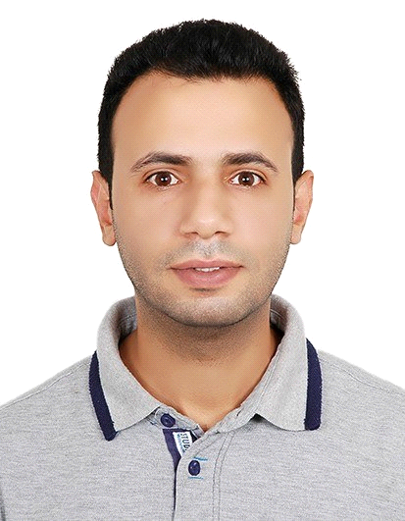

SALIM SBAI

Specialty: Accounts-Assistant
Cashier (cash handling and currency exchange)
Email: salim-390354@2freemail.com

Academic qualifications:

- Baccalaureate Level (2005-2006)
Assafoua High School – sale morocco
00212 537 80 84 34

Languages Proficiency:

Arabic = Mother Tongue
Italian = Fluent
English= Good
French = Good
TOEFL (under preparation)

Computer Literacy:
Good computer skills (word, excel, power point…)

Work Experience:
. Accounts Assistant 2014-2018 ( ZOURJAD ISOLATION )
Maghrib arabi C N-40 Appt n-6 2eme Etage _ Kenitra, MAROC

- CASHIER (Exchange House) 2011-2014
(Cash Society 1462 SARL) Sale Morocco

- SALES ASSISTANT 2007-2010
Chez saoudi

Training courses

- Customer Service and Telephone Skills

- Persuasive Selling Skills

- Quality in Satisfying Stated and Implied Needs of the Customer

Related Skills:

- High Communication Skills , Team work orientated

- Ability to work under pressure and in Hardship situations

- Committed, Enthusiastic and reliable

