CONTACT

Power charge

Tally Erp9

Quick Books

Accounting & Vat

Ms office Suite &

Outlook

Languages

English Hindi Tamil

Passions
SAMUEL
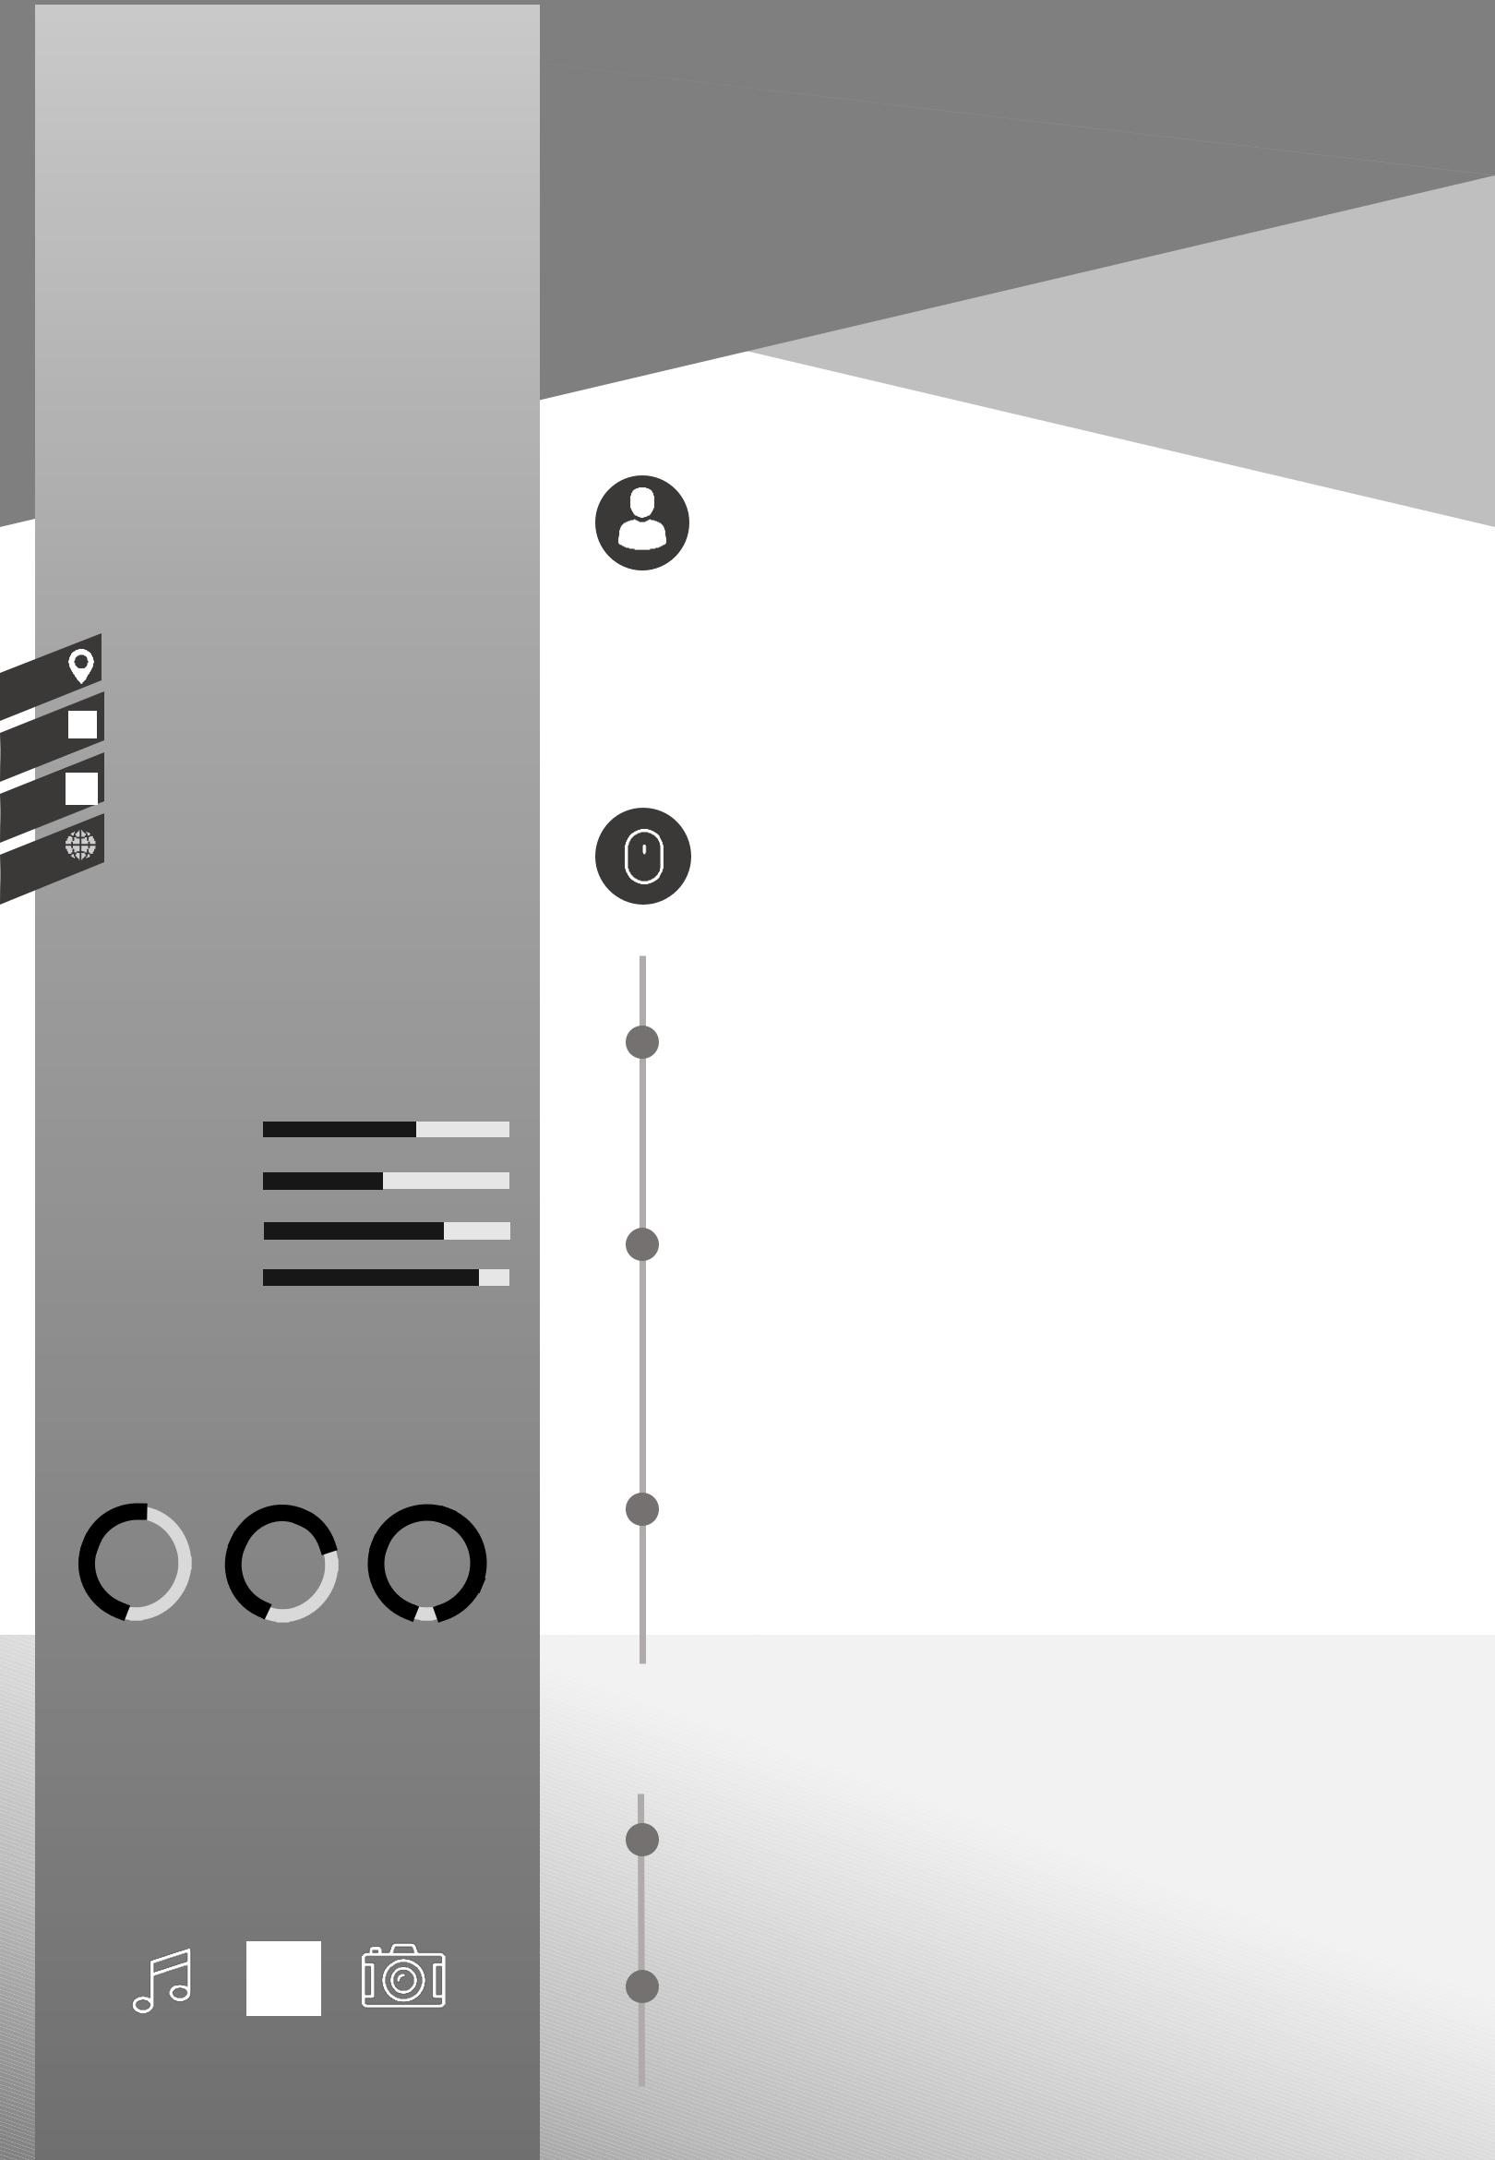
Accountant

Email: Samuel.390428@2freemail.com

About me

Excellent Accounts training, broad academic and practical experience in Finance and Accounting methodologies and practices. Seeking a challenging Accounts position in the esteemed organisation.

Experience

2004 - 2018

Shining Stars centers for Youth Development Accounts.Manager-Hyderabad -India. Finalization of Accounts, Filing Taxation & Office Administration.

2000 - 2004

Pissay & Co, Chartered Accountants-Hyderabad, India. Audit Assistant & Filing Taxes
Education

1995 - 1997
Bachelor of Commerce-Business, Accountancy & Taxation-Osmania University, Hyderabad-India

2017

Financial Management CIM, Chennai---Finance, Income Tax, FCRA, Corporate and Project Management

