CAREER OBJECTIVE

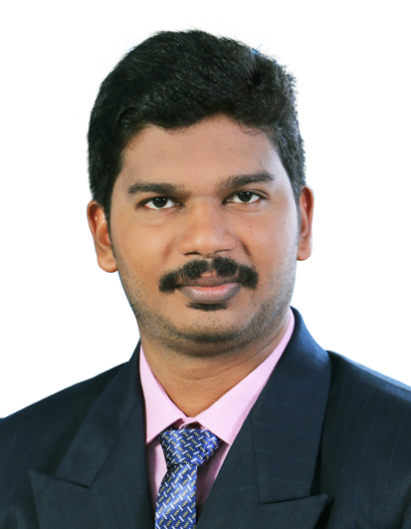

SARATH
Electrical Engineer

Email id: sarath-390436@2freemail.com

PERSONAL INFORMATION

Age & Date of birth: 27, 05/02/1992
Nationality : Indian
Marital status : Single
Interests : Sports, Books, Music&Net Browsing
Visa : Visit till 19-5-19

SKILLS & ACHIEVEMENTS
AutoCAD
MEP Electrical Designing
Relux Lighting Software
LV Panel manufaturing
Microsoft Office
Got Certificate Of Appreciation from Marine Electricals Pvt.Ltd in 10/3/2018

To work in a stimulating environment and to work in a professional, involving and challenging ideas that will utilize my acquired knowledge, educational, communicational and professional skills to serve the firm to the best of my efforts.

EXPERIENCE

- Worked as MEP Site Engineer in Aghora infrastructure kollam from 2.05.2018 to 27.12.2018
- MEP based load calculations, designing and site supervision.
- Preparation of Single Line Diagram, Load schedule, Cable sizing calculation.
- Preparation of Lighting & Small power layout.
- Lighting design with Relux software.

- Worked as Production Engineer in Marine Electricals Pvt Ltd, Goa for 1 year(13.4.2017 to 16.4.2018)
- Involving the production process of HT and LT Panel boards
- Stage wise quality checking during production process
- Checking & Installing ACB,VCB,MCCB etc

- Worked as an act graduate trainee at the QA & Electrical Maintenance department of Traco Cables Ltd Thiruvalla, Kerala for 1 year(14.10.2015 to 13.10.2016)
- Production & Testing of ACSR & XLPE Cables
- Testing includes electrical tests like High Voltage test, Megger test, Partial discharge test ,Impulse test ,Conductor resistance test and Mechanical tests

- Worked as an engineering trainee at the Electrical Maintenance department of Kerala Minerals and Metals Limited[KMML] Chavara ,Kerala for 6 months(12.01.2015 to 11.07.2015)
- Erection, operation, preventive, predictive/breakdown maintenance of: 110/6.9KV,10/13.5MVA Power Transformers,6.6KV MOCBs,VCBs,110KV SF6 Circuit Breakers ,Load Break Switches, Control Transformers, 6.6/0.433KV,1000/1600KVA Distribution Transformers, Capacitor Banks, HT Motors up to 1.25MW

- Erection ,operation, preventive, predictive/breakdown maintenance of: VFD control of AC motors, Air Circuit Breakers up to 3200A,Motor Control Centers(MCC),Power Control Centers(PCC),AC motors up to 250KW etc.

- Worked as an Electrical Site Engineer for 6 months at Aghora Infrastructure Kollam (04.12.2013 to 04.06.2014)
- MEP based Electrical Design of an Apartment Tower(100flats)
- Electrical Design of a Commercial Building
(That includes Selection of transformer, generator, LV Panels, cables and bus bar)

RESPONSIBILTY

PERSONAL

Motivating & Goal Oriented
Having Leadership Quality
Ability to be a Good Team Player
Ability to Tackle Critical Situations
Honest & hardworking
Positive attitude
Self-motivator

EXTRACURRICULAR ACTIVITIES

Active Volunteer of National Service Scheme (NSS)
Member of College Cricket, Football Team
Active Member in Arts Events

(2011)
EDUCATION

Year | Institution | Degree Name with Percentage of Marks
2009-2013 | MUSALIAR COLLEGE OF ENGINEERING & TECHNOLOGY,  PATHANAMTHITA | B TECH  Secured an aggregate percentage of 61.15 in Electrical & Electronics Engineering under MG University.
2007-2009 | SVGV HSS  KIDANGANNUR | PLUS TWO  (Board Of Higher Secondary Examination, Kerala) Aggregate percentage:[79%]
2006-2007 | MSHSS  RANNI | 10 TH  (Board Of Public Examination, Kerala) Grade Point: 8.5

PROJECT AND SEMINAR

PROJECT;
DEVELOPMENT OF ROAD LIGHTING INTELLIGENT CONTROL SYSTEM BASED ON WIRELESS NETWORK

SEMINAR;
GROUND PENETRATING IMPULSE RADAR FOR LANDMINE DETECTION

TECHNICAL EXPERTISE

Programming Languages | C, MS OFFICE, Conceptual-Microprocessor 8085,Microcontroller 8051, AutoCad, Relux software, MEP Electrical designing
Operating Systems | Microsoft Windows

