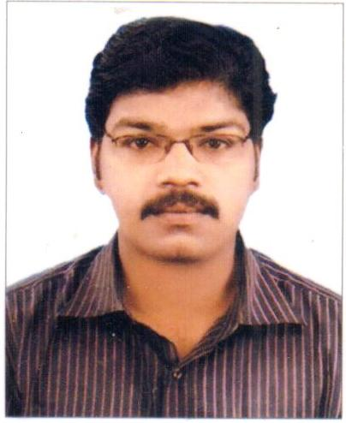
VIPIN

Email: vipin.390445@2freemail.com

Personal Details

Nationality | Indian
Languages | English : fluent (reading ,writing, & speaking)  Hindi : fluent (reading ,writing, & speaking)  Malayalam : fluent (reading ,writing, & speaking)  Tamil : (speaking only)
Date of Birth | 10th Oct 1983
Marital Status | Married
Driving license | Holding UAE valid Driving License.

Career Objective

To secure a challenging and responsible position in an organization that can offer me an opportunity to apply my skills and to develop my potentials in the field of Mechanical engineering.

Education & Courses

- Bachelor of Engineering in Mechanical Engineering from Bharatiya Gurukula Vidhya Peedam Tamilnadu.
- Diploma in Autocad from Tamilnadu Computer Education Development Scheme.
- Training Certificate from Canorous infotech for CAD-Pro-E,CAE-Ansys.

Job Profile and Professional Experience in U.A.E

- Project Engineer, Site Engineer, Procurement Engineer, Tendering & Estimation Engineer.
- Firm : Elemec Electromechanical Contracting L.L.C, Dubai.
Period : April 2010 to October 2016.
- Firm :Power Factor Electromechanical Co. L.L.C ,Dubai.(Al arif Group)
- Period :October 2016 to January 2018.

Positions Date ; From – To

- Project Engineer / Site Engineer for Plumbing , Drainage and Fire fighting works.(from 2012 to Till date)

- Procurement Engineer – Handling Enquires ,Price negotiation and Price comparison for Plumbing , Drainage and fire fighting materials.(2011 to 2012)

- Tendering ,Estimation Engineer for Plumbing ,Drainage and Fire Fighting services.(2010 to 2011)

Projects

- Mechanical Project Engineer (Plumbing, Drainage and fire fighting services) for B+G+P+19+Roof Residential building at Sports City, Dubai.
Consultant: ART Consultant

- Mechanical Project Engineer (Plumbing and Drainage services) for G+4+Roof Residential building (7 Nos) at Al Barsha South 3.
Consultant: Golden square engineering
Client: Ali Property Investment (API)

- Mechanical Project Engineer (Plumbing and Drainage services) for G+6+Roof Residential building (2Nos) at Al Barsha South 3.
Consultant: Golden square engineering
Client: Ali Property Investment (API)

- Mechanical Project Engineer (Plumbing, Drainage and Fire fighting services) for G+13+Roof Commercial and residential building at Al Barsha-1.
Consultant: Design Concept
Client: Badri

- Mechanical Project Engineer (Plumbing, Drainage and Fire fighting services) Nikki Beach Hotel and Resort –Phase- 2, Residence 1 and 2 at Pearl Jumeirah, Dubai
Consultant: DSA & WME
Client: MERAAS

- Mechanical Project Engineer (Plumbing and Drainage services) Badri Villa at Jumerah.
Consultant: Design Concept
Client: Badri

- Mechanical Site Engineer (Plumbing, Drainage and Fire fighting services) for 2B+G+13+Roof Commercial and Residential building at Al Barsha-1 (EROS house Office).
Consultant: Design Concept
Client: Badri

Responsibilities

- Communicate and cooperates effectively with project manager and other project participant to provide assistance and technical support.
- Monitor compliance to applicable codes, practice, QA/QC policies, performance standards and specifications.
- Forecasting, assign responsibilities and mentor project team.
- Site progress updating and reporting to project manager.
- Review engineering deliverables and initiate appropriate corrective actions.
- Alter and modify design to meet requirements in co-ordination with the consultants to eliminate malfunctions.
- Identify, formulate and produce effective solutions to emerging problems.
- Installation and monitoring of functional and overall progress of work done.
- Weekly meeting with consultants and main contractors.
- Tender Estimation and BOQ preparation.
- Designing of systems.
- Preparing the material submittal, shop drawing & As built drawing.
- Handling Enquiries and price comparison.
- Preparation of method statement.

Other Information
- Work Experience : More than 8 years experience in Dubai.

- Skills : Good communication skills, Organize Products, and ensure that these products meet Specifications and adhere to Safety Regulation , Self-motivated and dependable.

