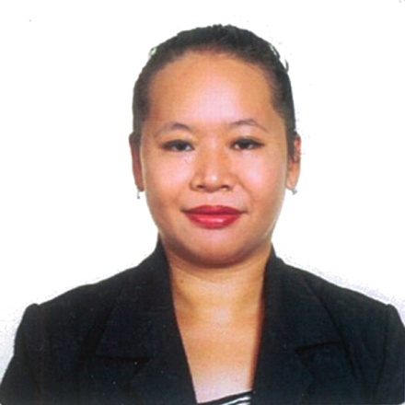
KRISTINE
Email: kristine-390447@2freemail.com
Visa Status: Visit Visa

Objective: To bring my strong sense of dedication and motivation and to utilize my skills and qualification obtained through my experiences and knowledge.

PERSONAL PROFILE:

Birth Date: October 3, 1987
Age: 30 yrs.old
Birth Place: Los Baños, Laguna
Gender: Female
Height: 5’2
Weight: 68 kg
Civil Status: Married
Citizenship: Filipino
Religion: Roman Catholic

EDUCATIONAL ATTAINMENT:

College: Bachelor of Science in Business Administration
Major in Finance and Accounting Management
TRACE COLLEGE
El Danda St. Batong Malake Los Baños, Laguna
2008-2009

Secondary: South Hill School Incorporated
College Los Baños, Laguna
2003-2004

Primary: South Hill School Incorporated
College Los Baños, Laguna
1997-2000
Science and Technology School
Paciano Rizal Bay, Laguna
1996-1997

WORK EXPERIENCES:

October 16, 2015 – September 1, 2018

Head Waitress at MONTE VISTA RESORT, PANSOL CALAMBA LAGUNA, PHILIPPINES

- Ensures the quality of food and it served with satisfaction of all the guest’s
- Accommodates customer complaints and handles them right away
- Checks if his/her co waiters do the SOP of the resort
- Supervises the team to achieve the best service for the customers
- Monitors if the waiters do the 3 minutes check and the 3 bucket system
- Time to time oversees to their operating procedures
- Performs the start and end of day process
- Double-checks the quality of the cleanliness of the area
- The one who trains newly hired waiter / waitress and make sure that the guest has a good experience with the service

April 24, 2012-March 26, 2015

Treasury Assistant at Waltermart Supermarket Inc. Ground floor, Olivarez Plaza Batong Malake Los Banos, Laguna

- Accounts daily remittances of the cashiers
- Handles and safe-keep the company’s fund
- Deposits daily cash sales to the affiliated bank
- Performs audit of supplier’s invoice
- Reconciles sales variances reports
- Monitors cell card sales weekly, determines its accuracy and updates variance
- Relieves other staff members such as IT and counter checkers

April 27, 2010- April 23, 2012

Counter Checker/ Treasury Reliever at Waltermart Supermarket Inc. Brgy.Real Calamba, Laguna

- Acted as team leader in the front end area
- Handled and processed corporate accounts
- Started and ended the cashier’s day process
- Processed discounts for seniors citizens and voided wrongly punched merchandise

November 2008- March 2009

Student Assistant at World Fish Center Los Baños, Laguna

- Data Encoder

April-May 2007

English Trainer at Asian Mission Center UPCO College Los Baños, Laguna

- Teach English language to Korean student nationals
TRAININGS/SEMINARS ATTENDED:

NATIONAL CERTIFICATE II
Food and Beverage Service
TRACE COLLEGE
El Danda St. Batong Malake Los Baños, Laguna
October 29, 2018

NATIONAL CERTIFICATE II
Housekeeping
Community General Hospital
San Pablo Laguna
October 23, 2018

World Food Expo 2018
SMX Convention Center Pasay City and World Trade Center
August 4,2018

Basic Life Support Training
Monte Vista Hotspring and Conference Resort
March 19, 2018

Water Safety and Rescue and Basic Life Support
Monte Vista Hotspring and Conference Resort
July 9, 2018

Anti-Money and Laundering Act of 2001
SM Corporate building F J.W. Diokno
Boulevard Pasay, Metro Manila
July 7, 2016

AMLA and compliance Training
Waltermart Corp. Building Quezon City
November 25, 2015

Personal Effectiveness
Waltermart Corp Building Quezon City
March 26, 2012

The Praxis of Research in Tertiary Level
Trace College
February 14, 2008

Learning Exposure Program
Calla Lily Hall Oxford Hotel, Clarkfield Pampanga
October 4, 2007

Microsoft Office Specialist Test
Trace College Center, Makati City
March 15, 2006

Open Source: Desktop Solution
Teatro Genuino, Trace College Los Banos, Laguna
September 27, 2005

Disaster Management
Trace College
September 24, 2005

