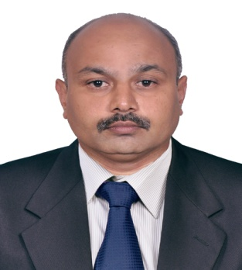
Madhavan

E-mail: madhavan-390458@2freemail.com

 | Objective
 | To realize, develop and utilize one’s potential in the arena of accounting and Office Administration or Sales Department to work with a team for achieving organizational and personal goals.
 | Strengths
 | - Ability to learn things quickly, independently |  |  | - Knowledge of accounts
 | - Dedicated and result-driven  - Ready to work at post of Sales Man |  |  | - Sincere & Hardworking
 | Education
SSLC KERALA EDUCATIONAL BOARD 40 %

PRE – DEGREE CALICUT UNIVERSITY HISTORY 42 %

Computer Diploma Honours Diploma in Computer Science
At Lakhotia computer center, Palakkad, Kerala, South India.
Diploma in advanced software Technology at ICA Computer centre, Coimbatore.
DTP under Windows with Pacemaker &Corel draw at National computer centre , Palakkad.

Diploma in Financial management ( Basic course) at All India council for management studies , Chennai

 | IT Skills
 | Accounting software & applications | : | Tally9, Pagemaker, DTP, DAST in ICA, HDCS.  TALLY EXPERIENCE DETAILS  TALLY ERP – 9  01 RECEIPT ENTRY  02 PAYMENT ENTRY  03 JOURNAL ENTRY  04 RECONCILIATION  05 INTER BRANK RECONCILIATION BRANCH WISE  06 SALES ENTRY  07 CREDITORS  08 DEPTORS  09 TRAIL BALANCE (BASIC)  10 INCOME & EXPENDITURE STATEMENTS  11 TERM LOAN A/C  12 LEDGER CREATION  13 BRANCH & DIVISION  14 CC & OD A/C BANK ACCOUNTS  15 SALES TAX BASIC ENTRY
 | MS Office Applications | : | Word, Excel, PowerPoint & Outlook,
 | Platforms used |  | Windows7, XP, Windows 98, 2000.  Experience Summary
Presently working in Dubai at leading facility managmentcompany,from 20/12/2015 to till date.

Two years experience in Spare parts sales department - Bajaj Dealer at Palakkad. 1997 – 1999 (up to Sept) -

2000 – 2015
Arsha Yoga Vidya Peetam Trust
[Sister Concern of The Arya Vaidya Pharmacy (Coimbatore)Ltd]
Arsha Yoga Vidya Peetam Trust is a Training School that imparts Authentic Education in Ayurveda, Yoga, and other allied Traditional systems of India

Designation: Accounts – cum – Admin Assistant.
Profile:
- Accounts Receivable follow-up – Local, & International Customers.
- Maintaining Books of Accounts
- Office Administration
- Handling Petty Cash and preparation of Petty Cash report and cash book.
- Local purchase – stationery items, etc.
- Reconciliation of related company statement and fund transfer arrangement for the same.

Personal Details
Nationality  Gender | :  : | Indian  Male
Date of Birth  Marital Status | :  :  : | 18.03.1978  Married
Languages | : | English, Hindi, Tamil, & Malayalam

