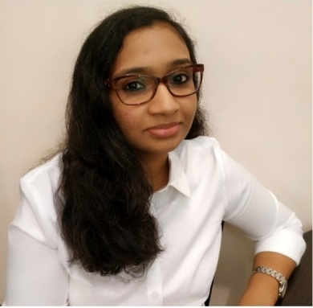 |  | karthika rejin  LV SWITCHGEAR ESTIMATION ENGINEER
Profile  Detail-driven electrical estimator with 2.5 years of experience in both contracting and switchgear industry.  Exhaustive knowledge of various UAE authority & consultant regulations for effective costing of products and services. Experience in dual field – contracting and switchgear brings with me immense experience which company can put into its benefit.  CONTACT  EMAIL:  karthika-390478@2freemail.com  personal dossier  Languages:  English, Hindi, Malayalam and Tamil  Visa Status:  Spouse Visa (Valid till may 2020) |  | EDUCATION  BACHELOR OF TECHNOLOGY- ELECTRICAL & ELECTRONICS - 8 CGPA  KERALA UNIVERSITY, KERALA 2010 – 2014  WORK EXPERIENCE  AL RAFAHEYA - ESTIMATION ENGINEER  (APRIL 2018–PRESENT)  *Selection of components ensuring compliance with project requirement and standard regulation. * Preparation of cost estimates based on the design. * Responsible for outlining a production chart for achieving delivery schedules for the projects.* Responsible for encouraging and guiding workforce to attain the set goals in stipulated frame.  TECHNOBUILD MIDDLE EAST LLC - QUANTITY SURVEYOR  (AUGUST 2016 – FEBRUARY 2018)  Review of Tender documents on receipt to ensure its completeness  Developing accurate and timely electrical estimates and submit competitive bids and proposals for our client-base Analyse and interpret detailed clients’ requests, drawings and specifications. * Determine and price value-engineered alternatives to plans and specifications * Utilising standard quotation letters submit bespoke, proposals/quotations to our clients  KERALA STATE ELECTRICITY BOARD – TRAINEE ENGINEER  (AUGUST 2014–MARCH 2015)  SKILLS

