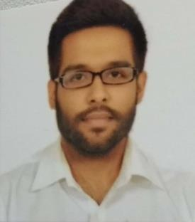
Anshul

E-mail: anshul-390554@2freemail.com

Profile

Strengths

I look forward to a career that provides me an opportunity in the field of finance to improve my knowledge and personality, offering a challenging working atmosphere and involves working with the people having diverse capabilities and personalities as a team.

- Hard Working individual

- Self confidence and performance management

- Effective planning and coordination.

C a r e e r P r o g r e s s i o n

Hinduja Global Solutions (Amazon)
Trainee Officer/ Customer Care Executive October 2016 to November 2017

- Responsible for maintaining meaningful relationships with Existing and new Customers and create a sense of customer satisfaction by providing accurate and timely information.

- Responsible to provide the customer with a feeling of trust, assurance and competence, while being able to work with the company to get things done in a timely manner.

- Responding quickly and efficiently to all in-coming enquiries, by telephone and email.

- Maintaining and updating the database regularly.

- Responsible for maintaining a peaceful and efficient work environment.

- Coordinating and responding to all requests of internal meetings by making appropriate arrangements for it.

- Resolves product or service problems by clarifying the customer's complaint; determining the cause of the problem; selecting and explaining the best solution to solve the problem; expediting correction or adjustment; following up to ensure resolution

Academic Qualifications

Graduation- Bachelor in Commerce (Foreign Trade)
Completed: 2018
DAVV University, India

Summary of Skills

- Ability to manage multiple tasks in a challenging environment.
- Ambitious and with a desire for personal and career advancement.
- Team player but with ability to work independently as well.
- Numeric aptitude, good inter-personal skills and group skills.
- Knowledge of Foreign trade programs and Regulations, International Import/ Export Laws.
- Proficient in MS Office Package (Word, Excel & PowerPoint), Internet and E-mail applications

Other Details

Nationality : Indian
Date of Birth : 7th June 1995
Marital Status : Single

Visa Status : Visit (UAE)

