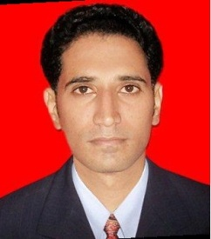
MIR HADI

Email: mirhadi-390625@2freemail.com

Aspiring for senior level assignments within organization offering 11+ years of experience in Sales, Marketing, Business Development and Customer Relationship Management, was associated AS Branch Operations Manager– TATA MOTORS FINANCE LIMITED. JALNA Branch
Profile Summary  - Seeking for a Senior Management Profile position in a growth oriented organization in the area of Marketing & Sales where I can work constantly for upgrading my knowledge and skills and in turn be responsible for the growth of the organization.  - Proficient in cementing healthy relationship with the clients for generating business and leading workforce towards accomplishing business & corporate goals.  - Steered business operations for the profit center with a view to realize pre-planned sales and revenue targets; formulated profit center budget for operational / business development activities.  - Effective organizer, motivator, team player and a decisive leader with the skills to drive teams to excel & win.  - Expertise in analyzing existing systems and procedures, designing internal control systems and facilitate effective decision-making..  - Managing Distributor’s Return on Investment (ROI) by rationalizing Investments, budgetary control and driving efficiency of costs leading to consistently growing business  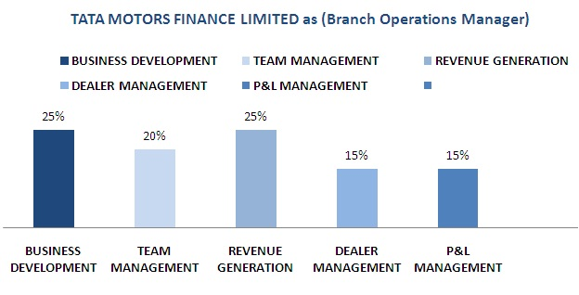 | Core Competencies  COMMERCIAL VEHICLE LOAN  CORPORATE STRATEGY  BRANCH MANAGEMENT  RISK MANAGEMENT  TARGET ACHIEVEMENT  TEAM HANDLING  LEADERSHIP SKILLS  RECOVERY MANAGEMENT  DEALER DEVELOPMENT  P& l ACCOUNTABILITY  Academic Credentials  - BSc. Computer Science - 2006 Deogiri College , Aurangabad  - HSC - 2002 Milind College, Aurangabad  - SSC – 2000 Little Flower High School, Aurangabad  Personal Details  Date of Birth : July 26, 1984  Languages known : English, Hindi, Marathi, Urdu

|VEHICLE LOANS | BANKING | FINANCIAL SERVICES |OPERATION MANAGEMENT |COMMERCIAL LOAN /CVL |

AREAS OF EXPERTISE

- Disbursements of Loan
- Terminations of Loans
- Bank Depositions
- Bank Reconciliation
- HHM & TAB Management
- MIS and Report
- Accounting
- Time management
- Leadership
- Revenue Generation
- Relationship Built-up
- Decision-making

Professional Experience

Branch Operations Manager- Jalna Maharashtra Nov 2011 to Oct 18
TATA MOTORS FINANCE LIMITED
Growth Path
Sr. Branch Operations Executive Nov 2011 to 21st Jan 2017 -Aurangabad Area, Maharashtra INDIA
Branch Operations Manager Jan 2017 to 17th Oct 2018 -Jalna Area, Maharashtra INDIA

FOCUS Area’s –
| DEALER MANAGEMENT | BRANCH MANAGEMENT | TEAM MANAGEMENT | REVENUE GENERATION | MIS MANAGEMENT|
Key Result Areas.
- Issue the Vehicle Release Order, Coordination with Sales for Login of Files.
- Maintain Records and Dispatch Document, NOC (No Objection Certificate) to RTO.
- Daily banking, BRS (bank reconciliation), Bank 1st PDC retained at the Branch on respective due dates
- Prepare necessary MIS for management, Handling daily cash and DD / cheques collection.
- Pre-closure and Terminations of Loan Contract, Monthly PDC Banking for Branch.
- Coordination with Collection Executives, Coordination with HO.
- Handling branch petty cash A/C & Keeping proper record, Checking accuracy of branch expenses bills & release timely payments.
- Attend to customers walking into the Branch with queries, Insurance related activities, renewals & policy handover
- Handle Account related activities, Hand-held device & TAB management.
- Collect cash payments made by customers & CRE’s at the Branch

Operations Executive Sept 2011 to 27 Nov 2011
BAJAJ AUTO FINANCE LTD.
FOCUS AREA’s –
| BUSINESS DEVELOPMENT | LEAD GENERATION | TEAM MANAGEMENT | ON JOB TRAINING |DEALER MGT|
Key Result Areas.
- Verification of documents, Disbursement of Loans, Dealer Payment and Trade Advance Mgmt.
- Check transactions as per approval grid, Receive file from marketing, Verify file received against operations check list
- Handover files to marketing for resolving discrepancies / queries if any
- Issue the Vehicle Release Order, Send contract files to Ho for booking, Coordination with Sales Executives.
- Maintain Records and Dispatch Document, NOC (No Objection Certificate) to RTO, Daily banking, BRS (bank reconciliation).
- Bank 1st PDC retained at the Branch on respective due dates, Prepare necessary MIS for management.
- Handling daily cash and DD / cheques collection, Pre-closure and Terminations of Loan Contract.
- Monthly PDC Banking for Branch, Coordination with Collection Executives.
- Coordination with HO, Pan Receipts records reconciliation and updating
- Handling branch petty cash A/C & Keeping proper record, checking accuracy of branch expenses bills & release timely payments.
- Attend to customers walking into the Branch with queries, Insurance related activities ¡ renewals & policy handover
- Handle admin related activities, Maintain stock of stamped agreement required and utilization before expiry date
- Maintain TAT as per company policy.

Operations Executive December 2009 to August 2011
HINDUSTAN UNILEVER LTD.- [ RS D'Hira & Company ]
Key Result Areas
- Doing daily billing of the salesman’s through the HHT palm sync process.
- Generating sales reports & maintaining a up-to-date record of the sales and targets.
- Generating collection reports & maintaining up-to-date record of the collection.
- Keeping a track record of the stock [SKU’s] as per HUL norms.
- Handling the SAP order page & placing the order as per the requirement in the HHT through the ZIP process.
- Day-to-Day Costing – Purchase, Sales & Day to day Cash & Cheque flow position.
- Follow up with Finance position, Co-ordination with Sales Orders.
- Day to day reconciliation with various Bank A/cs of Company as well as Petty Cash position.
- Reconciliations of Debtors as well as Creditors, Execution of Sales Orders in time, Over all day to day administration office

Proofreader Nov 8 to till Nov 09
TRANDYNE IT SERVICES PVT LTD. - Hyderabad
Key Result Areas
- Listening to the U.S doctors dictations files and makes the necessary changes wherever necessary after the file is transcribed by the Medical Transcriptionist such as correct grammar and vocabulary and ensures documents are delivered with 100% quality to the client, Doing editing of the files and formatting.
- Making the complete document 100% accurate to send to our U.S client

Customer Support Executive - Call Centre July 07 to Nov08
New Age Marketing - Hyderabad

Academic Project
LIC Management in BSc. Final Year
Language Used : Visual Basic, MS-Access
INDIAN NAVY Management In BSc. Final year
Language Used : Visual Basic, Oracle - SQL]

Programming Skills
Visual Basic, C, C++
Oracle -PL/SQL, MS Access.
MS-Office
Unix, Windows 2000/05/07/XP
Distinction, Honors & Achievements
Organizer of many events including fresher party, annual gathering
Active participant in college annual gathering.

