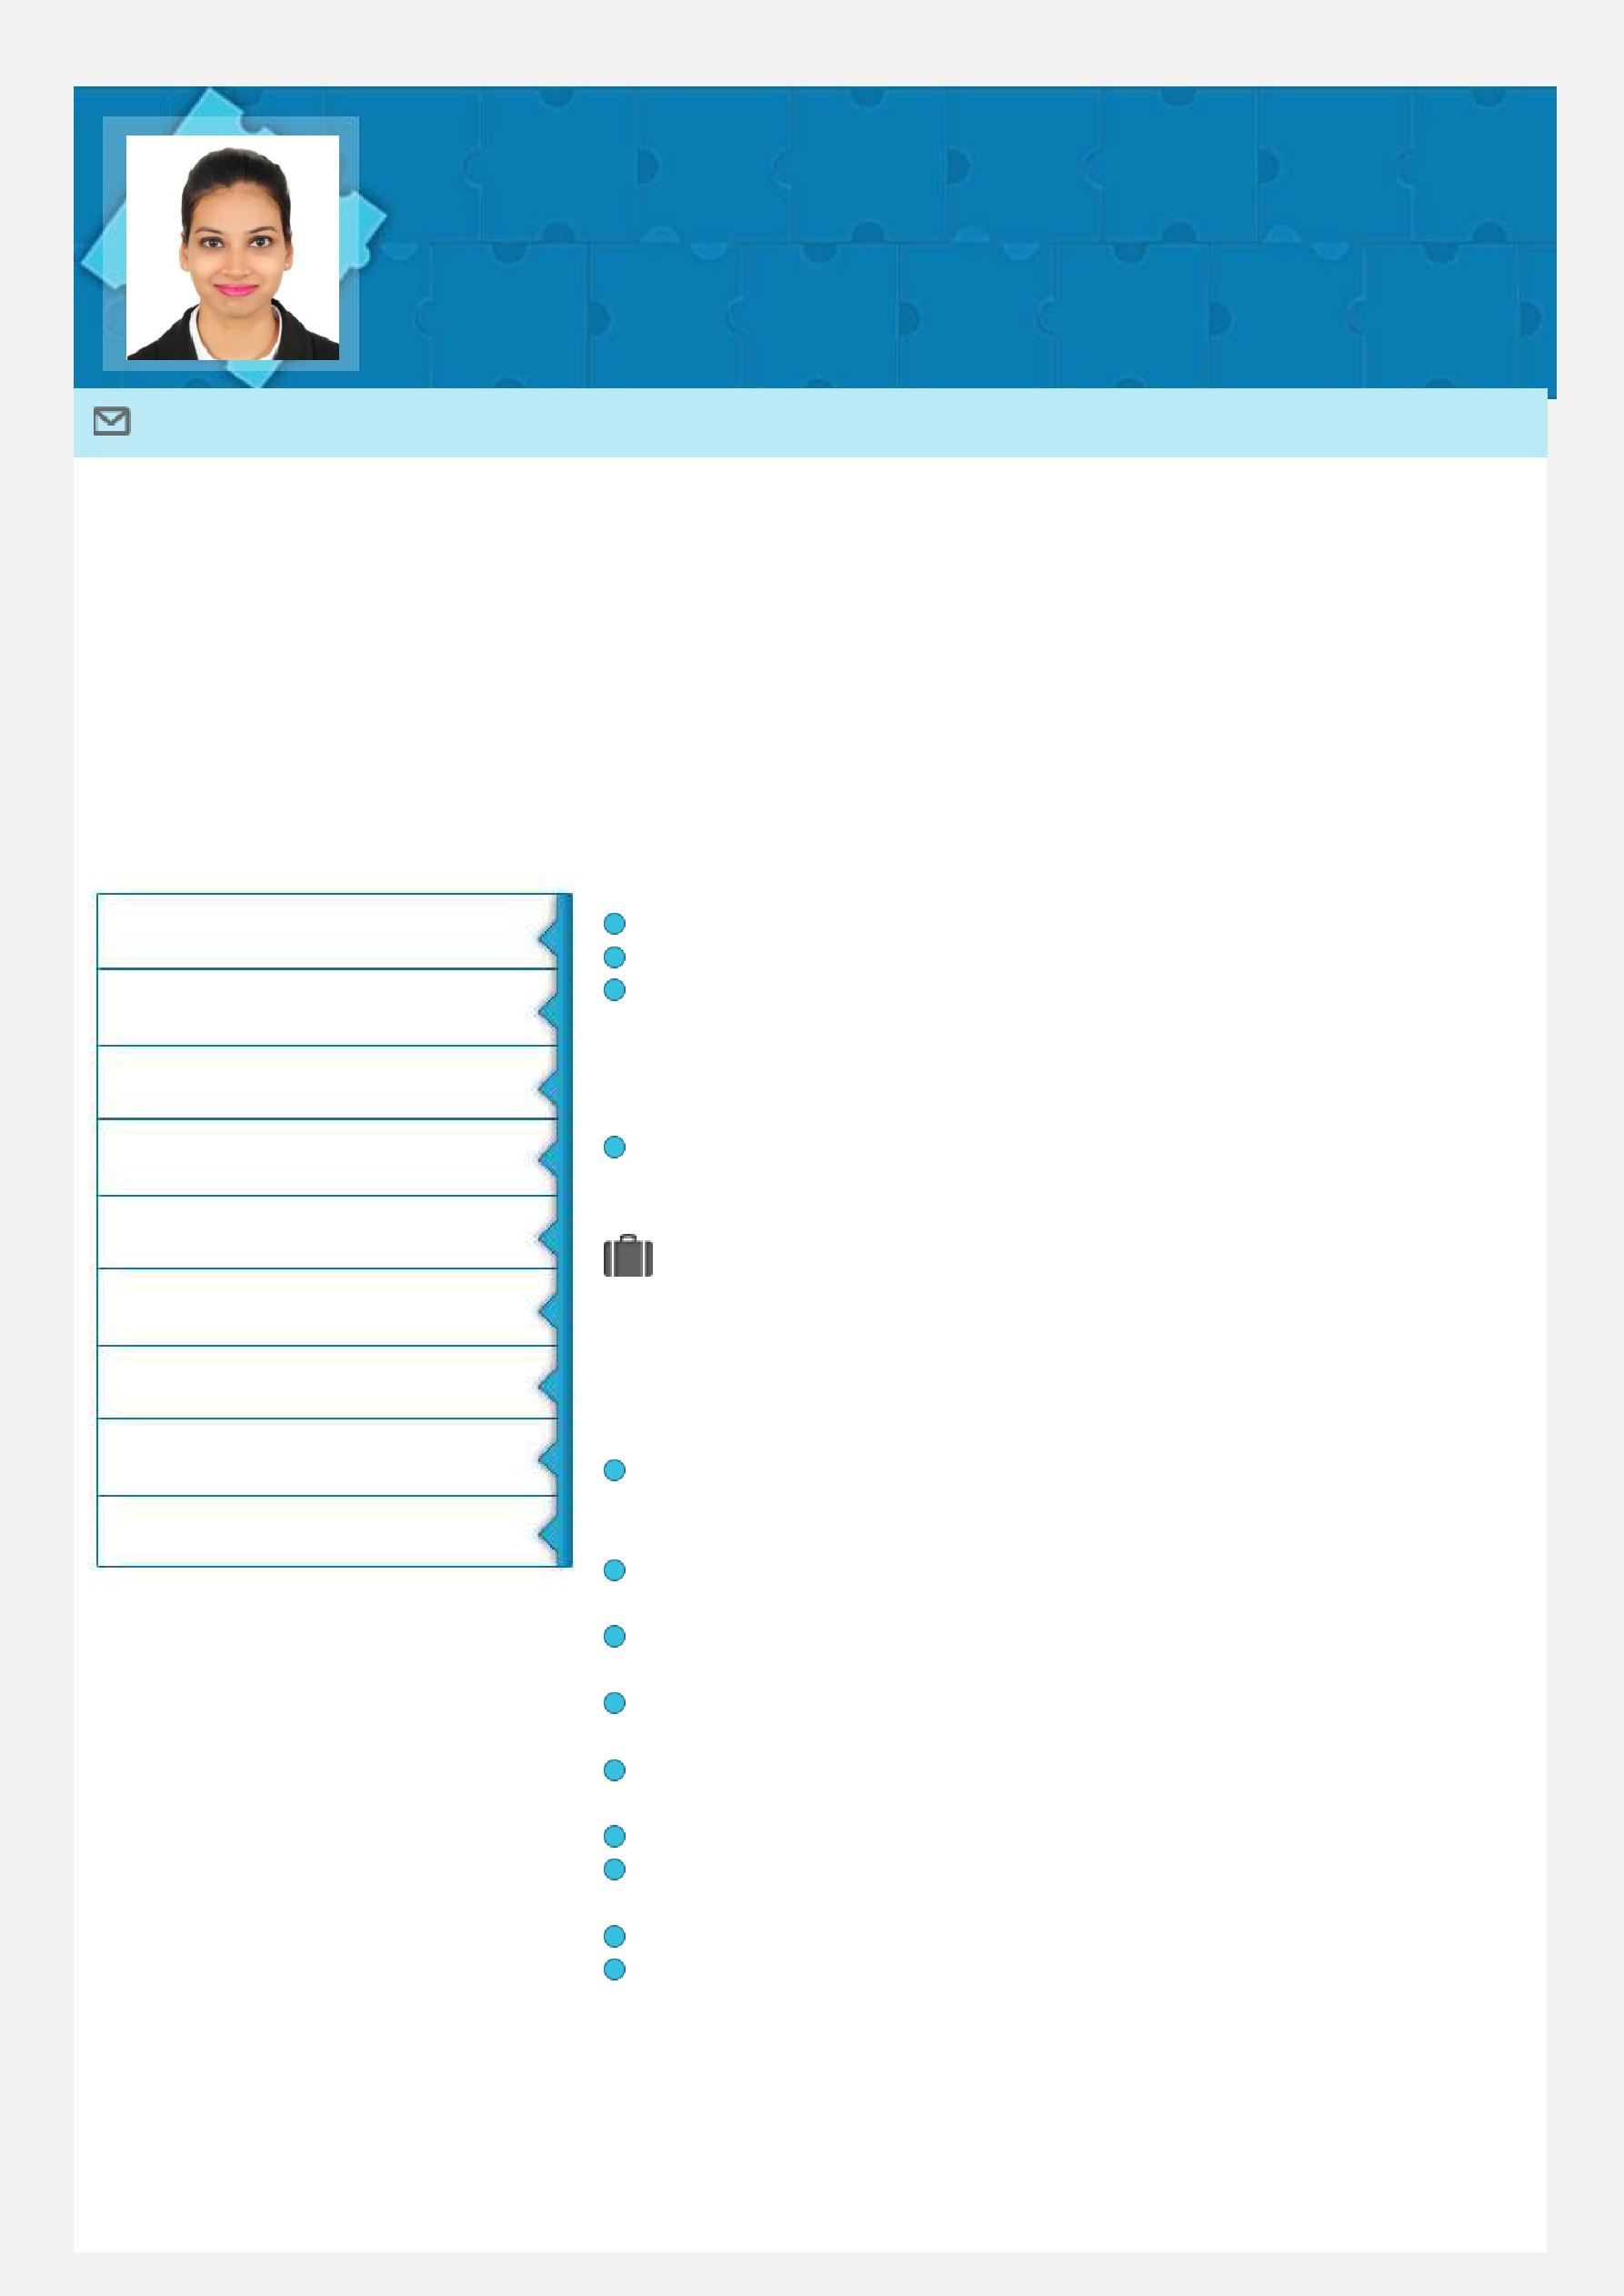
KAJAL
Combining strong Customer Service, Administration, Sales, Problem Solving Skill and hard work acumen to promptly establish efficiency, resolve problems and optimize productivity

Email: kajal.390758@2freemail.com

Profile Summary

Enterprising professional with nearly 2.7 years of proven success in impacting organization profitability through Customer Service, Administration, Sales Technique and Operational Excellence. Comprehensive exposure in luxury accessories, style & fashion and in understanding the FAB of the customers with proficiency in providing high value-added suitable choices to customer. Incisive acumen in directing framework for customer service, performance management, sales target and assessment for desired competency development in line with industry guidelines. Setting out standards for various operational areas; implementing procedures to facilitate a high-quality customer experience, while adhering to the SLA. Continuously leveraging strengths in innovation and creative problem solving to identify new opportunities and deepen existing relationships and satisfy objectives.

Core Competencies

Customer Service

Sales Target

Data Management

Complaint Resolution

Academic Details

Bachelor of Arts from St. Andrews College, Mumbai University, India in 2015

HSC from St. Andrews College, Mumbai University, India in 2012

SSC from St. Elias High School, Maharashtra Board, Mumbai in 2010

Technical Skills

Skilled in MS Office, Out Look , CRM, Alaya care, Online Tawkto, WordPress, BCT, Salesforce

Administration

Organizational Experience

Customer Delight

Process Improvement

Supervise in detail

Team Coordination

Skill Set

Motivator

Communicator

Collaborator

Positive Attitude

Negotiation

Problem Solving

Out spoken

Dec 17 – Feb 18 with Emirates Home Nursing ,Dubai (UAE) as Office Administrator

Key Results Areas:

Answer/make phone calls and attend online chats to assist clients query related to wide range of services offered and maintain detail record in Salesforce to manage task, sales and follow up

Make clients new bookings and assign best available nurse as per clients requirement

Manage clients bookings for amendments, cancellation as per clients requirement

Organize and schedule appointments of clients with Clinical and Commercial Manager post successive query turned sales

Develop and maintain a filing system of clients contracts, correspondence, organization documents, payment system and patients records Maintain proper documents filing of company Nurses and Drivers

Schedule nurse and driver roaster on a daily basis ensuring all the arears of clients expectation is met at the fullest
Write and distribute emails, memo and follow up on clients payments

Contact clients post service for customer satisfaction feedback report

Aug 15 – Dec 16 with Rivoli Group , Dubai (UAE) as Sr. Sales Associate - Retail

Motivator

Communicator Change Agent

Collaborator

Key Result Areas:

Understanding and providing assistance in satisfying customer needs & queries about products, prices and services
Advising customers on product ranges best suited to their needs

Achieving the sales target and focus on increasing sales by using advance sales techniques, focusing on up selling/ cross selling
Maintaining customer relationships in order to build long term brand loyalty

Handling new launches, promotion of products and visual merchandising

Ensuring stock replenishment at all times

Maintaining general cleanliness, hygiene standards and visual displays
Implementing CRM at the store level and providing relevant feedback

Coordinating with Customer Care Centre for after sales service

Generating Daily Sales Report and maintaining sales report in an excel Following all company procedures in ordering, cash handling and other common practices

Preparing and maintaining stock report

Ensuring best customer service all time
Providing administration service to Operation and Brand Manager

Highlights:

Handled two retail locations as Shop Manager/In-charge

Filled all positions by extensively utilizing innovative sales technique and sales strategy

Trained new joined employees under my firm supervision ensuring they learn and get complete knowledge about the product and services.

Successfully implemented 2 operational excellence plans, thereby leading to an increase in efficiency (product and sales)

Consecutively stood on top rank board for highest number of sale figure Best recognized for selling non-moving items by innovative sales strategy

Jun 13 – May 14 with Milan Optics, Mumbai (India) as Customer Service Representative/Receptionist - Retail

Key Result Areas:

Manage Reception area, including meet and greet to walk in visitors

Answer all telephone calls welcoming and greeting, respond to inquiries

Make entries of incoming calls in call log sheet (Excel sheet) with client details
Handle escalations of clients and query with strong problem solving skills

Respond to all email queries and maintain the correspondence

Maintain daily sales report with quantity and value
Administrative tasks/ Reception management outlined in Customer Service

Maintain good relation with suppliers and customer

Follow up with suppliers order and payment

Assignments and Notable Credits

Did group and Individual presentations on Power Point as part of college assignment

Visited NGO Care Centre and worked for 24hours giving everyday atleast 2hours as part of college assignment

Actively participated in dance during my academic years Awarded and Appreciated for best Customer Service Consecutively achieved highest sales target

Personal Details
Date of Birth: 13th July 1993
Religion: Roman Catholic

Languages Known: English, Hindi, Marathi and Konkani

Hobbies: Dance, Listening Music, Socialize

