CANDIDATE PRESENTATION 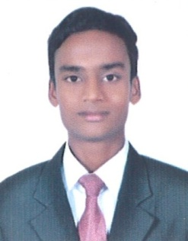

HANEEF

Email: haneef-391208@gulfjobseeker.com

PERSONAL DETAILS
Name | : HANEEF
Date of Birth | : 10/11/1997
Age | : 21
Gender | : Male
Marital Status : | SINGLE
Nationality | :Indian
Mother tongue | : URDU
Language Known | : ENGLISH,HINDI,URDU,TELUGU
Height | : 5ft.4incs
Weight | : 45kgs

CAREER OBJECTIVE
My career objectives are twofold. It is my goal to deliver my duties as my position to the fullest satisfaction of all members of (company)using my skills with customer service.
INTERESTS
FOOD & BEVERAGE SERVICE (Waiter)

EDUCATION QUALIFICATION

Completed : ONE YEAR PG DIPLOMA IN HOSPITALITY MANAGEMENT
Completed Secondary School Certificate: INDIAN MISSION SECONDARY SCHOOL
KNOWLEDGE ACQURIED
Food & Beverage Service: I have learnt : Rota service, Types of menu, French classification, Table Setup, Take Orders, Serve Food and Beverages, Customer Service.

INDUSTRIAL EXPOSURE TRAINING
● Completed 20 weeks of INDUSTRIAL TRAINING from HOLIDAY INN GOA from 9th April 2018 to
25th August 2018.
COMPUTER SKILLS
MS OFFICE

