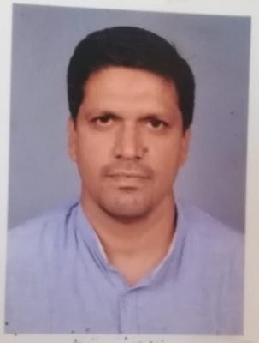
Sajith
sajith -391344@2freemail.com

Work experience

14 years of work experience as Ayurveda Panchakarma Therapist.

Current Position
Recently (06/12/17 to 30/04/19) worked as Ayurveda Panchakarma Therapist in Vaidyarathnam Treatment Centre, Thrissur (HO), Kozhikode branch.

Past Work Experience
- Worked as Panchakarma Therapist at ‘Shanthigiri Ayurveda Sidha-Vaidyashala’, Vishakhapattanam during 2005 – 2010.
- Worked as Ayurveda Panchakarma Therapist at Dr. Arya Devi’s ‘Sukrutham Ayurveda Chikilsalayam’, Kozhikode during the period 2010-2017.
- Worked as Ayrveda Panchakarma Therapist at ‘Vaidyarathnam Treatment Centre’, Kozhikode during the period of 06/12/17 to 30/04/19.

Other Credentials

- Thorough knowledge about all the Panchakarma, Upakarma and Keraleeya traditional ayurvedic treatments like Vamanam, Vasthi etc.
- Knowledge about the preparation of ayurvedic medicine like Kashaya, Kizhi etc. for Panchakarma treatments.
- Self confidence, communication and work skill.

Certificate

- Ayurveda Panchakarma Therapist Course by Sanjeevani.

Language Proficiency

English and Malayalam

Objectives

I look forward to a challenging opportunity in order to acquire the best professional experience and I believe that I posses the right attitude, confidence and zeal to learn and assimilate the principles, learnt through diligent application.

Personal Profile

Date of Birth : 21st May 1978
Sex : Male
Marital Status : Married
Nationality : Indian

