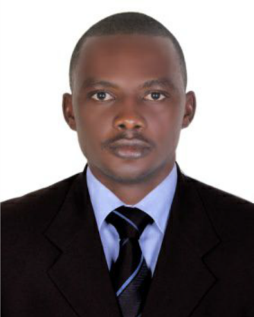
JOB TITLE : WAITER

Name : Masango
Marital Status : Single
Gender : Male
Nationality : Cameroonian
Visa status : Cancelled Visa
Email : masango-391394@2freemail.com

CAREER SUMMARY

A professional waiter highly effective at anticipating and accommodating customer needs. Friendly , punctual and enthusiastic team player. Hardworking waiter who thrives under pressure and goes above and beyond to create unforgettable guest experiences. Over 3 years experience serving as a waiter in upscale restaurants. Customer-oriented waiter with excellent interpersonal and communication skills. Food and beverage expert. Have an award as best worker of the year.

SKILLS AND ABILITIES

Customer Service Skills

- Highly skilled in talking to customers.
- In-depth knowledge of customers directions.
- Hands-on experience to operate customer techniques.
- Able to understand and follow all service precautions and work related directions.
- Interpersonal skills:- outgoing and friendly,Polite and courteous,engaging,sociable,problem solving,service oriented,ability to work in a team.
- Sales and marketing skills.

Communication Skills

- I am an attentive listener and an engaging communicator.
- Confident when communicating with guests.
- Intuitive in nature
- Fast learner.
- Have a good memory.

Multitasking Skills
- Have a proven ability to manage several things at once.
- I have good sense of awareness.
- Capable to bus and clean tables.
- Having the ability to input order.
- Efficient handling of money.
- Very attentive to details.

ABILITIES
- Taking orders accurately.
- Sensitivity to food allergies/ intolerance.
- Knowledgeable in basic math.
- Adhering to company's policies and procedures.
- Standing for long hours.
- Can work under pressure.
- Serving a wide range of guests.
- Willing to be flexible in my working patterns.
- Very time conscious.
- Demonstrated ability to accomplish physically challenging tasks.
- Having the ability to master the menu.

PROFESSIONAL EXPERIENCE

WAITER,2015 - present; Al fakhar Mandi restaurant; Backyard BBQ restaurant.

Responsibilities

- Greeted customers and escorted them to their tables.
- Presented menu and answered questions about the cuisine, made recommendations upon request.
- Recommended drinks to customers.
- Wrote customers’ orders and conveyed to kitchen staff.
- Took orders from customers and served food, drinks and desserts.
- Served specialty dishes to customers at tables as required.
- Checked to ensure that customers were enjoying their meals; took actions to correct any issues as needed.
- Prepared bills/receipts and collected payment from customers.
- Cleaned tables and other areas as needed after clients depart.
- Greeted guests politely as they left; assuring them that it was nice having them around and hoped to see them soon.

ACADEMIC QUALIFICATION

Basic knowledge in hygiene and food safety.

High school certificate (2010)

