CURRICULAM VITEA

NAGARAJU

Nagaraju-391395@2freemail.com
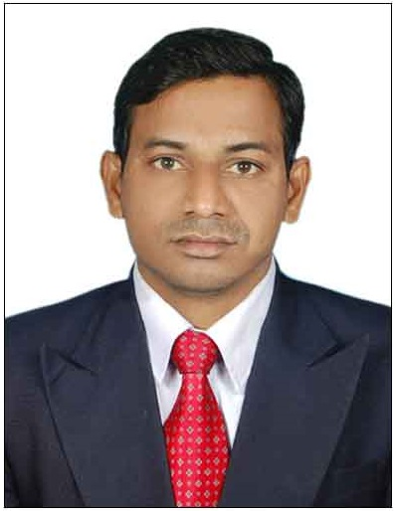  Personal Data  Gender : Male  Nationality : Indian  Religion : Hindu  Passport : Available  Date of Birth : 31-10-1985  Marital Status: Married  Languages Known  - English  - Hindi  - Telugu  PROFESSIONAL EXPERIENCE  Tower Crane& Passenger HoistElectrical Installation &Dismantling  Jan-2017 TO MARCH 2019  AL BASTHI & MUKTHA LLC  DUBAI, UAE  ELECTRICAL SUPER VISOR  Aug 2015 to Dec 2016  The Great Ruaha Group of Companies(SS) Ltd, Juba, South Sudan,(Africa)  ELECTRICAL IN’CHARGE  JUNE-2013 TO JULY-2015  Sri Sai Raja Rajeshwari Spinning Mills (P) Ltd.  ELECTRICAL IN’CHARGE  April 2012 to May 2013  Surabhi Spinning Pvt Ltd Suglam Pally  ELECTRICAL SUPERVISOR  May 2011 to April 2012  Seetha Rama Spinniers (P) Ltd Thuniki Kalsa, Vargal, Medhak, T.S.  ELECTRICAL FORMAN  Feb 2006 TO April 2011  Sri Sai Raja Rajeshwari Spinning Mills (P) Ltd. | CAREER OBJECTIVE  To work in a challenging and motivating environment, where my creative and analytical skills contribute in a major way towards the growth of the organisation that offers me an opportunity and professional growth.  SKILLS  - Operating &Handling 33 KV/11 KV/ 433 Volts PowerDistribution System.  - Good Hands on Tower cranes and passenger hoist. Electrical field  - Troubleshooting Skills & Managing Work Independently.  - Preventive & Predictive Maintenance Schedule Planning Daily, Weekly, Monthly and Year. (Schedule Planning about A.C Motors Oiling & Contactors, (Star & Delta, DOL) Starters, And More…), (Machines Calibrations).  - Good Experienced in Digital & Analogs Systems and Devices. Like – A.C & D.C Motor Drives, Sensors, Encoders, PLC, Timers, And More….  - Oparating & maintence Air Compressers Up to 500 CFM Capacity Units.  - Tracing of Circuit Diagrams, Application of Electrical and Electronic Components, Trouble Shooting, and Maintenance Display parameters.  - Relevant 12 Years Experience.  - Purchasing & Good Marketing Skills on Electrical Products.  ACADEMIC CREDENTIALS  - S.S.C. From Secondary School Education.  Technical Qualifications & Computer Proficiency  - Diploma in EEE (Discontinue)  - I.T.I Electrical Trade from Laxmi I.T.C. Metpally Mandal Karimnagar Dist. Scored as below…  - Trade Practical = 98%  - MS-Office, Internet Concepts & Mails, DCA,  STRENGTH  - Good at identifying issues and reporting them to the superior with my suggestions to resolve issues.  - Good Communication and Analytical Skills.  - Flexibility to work in different time zones.  Preferences – Ready to work in below industries & Areas  - All Manufacturing & Production Industriesand continue process Industries & Switch Gear companies,  - Electrical & Maintenance related all fields  - Tower Crane Electrical Maintenance  - Tower Crane & Passenger Hoist &Cradles, Troubleshooting & Solving Electrical Break Downs, & Electrical Installations and Dismantling of tower Crane & passenger Hoist &Cradles  (EXPERINCE IN CRANE MODELS LIEBHERR, HKTC, ZOOMLINE, SYM. AND PASSENGER HOIST MODLES GJJ AND ORBIT.)  Installation, troubleshooting and Electrical maintenance in water treatment plants.  - Tower crane electrical maintenance and troubleshooting all type of motors (DOL & STAR-DELTA” & All type of electrical Control wiring with all safety Control features ) with my team  - Service Contract inspections & Installations, product and Service sales on site customer communication.  - Operating & maintenance Air Compressors and Pneumatic Controls Systems.  - Preventive & Predictive Maintenance Schedule Planning Daily, Weekly, Monthly and Year. (Schedule Planning about A.C Motors Oiling & Contactors, (Star & Delta, DOL) Starters, And More…), (Machines Calibrations).  - Maintenance & Handling all types of Textile M/C Controllers. Digital & Analogs Sensors, Pneumatis Controls, Voltage frequency Drives (V.F.D). PLC, Servo Drives, Air Compressers. Operating & Handling 33 KV/11 KV/ 433 Volts Power Distribution System.  - New established Textile Yarn Manufacturing continue process Industries Company. All Type of Textile Machines Internal Control Wiring, Installations. All Type of Electrical Control Panels, Motors, Capacitors Banks and Lighting Distribution Panel System.  - Team Work Established by me for Up to 3.5 Core * 300 Sqmm Aluminium Armored Cables And Up to 3.5 Core * 240 Sqmm Copper Armored Cables Laying, Glading And Terminations under my guidence.  - Under Textile Yarn Manufacture Company my role was erection Machine Electrical Control Pannels, Main Power Control Pannels and Conlrol Breakers.  - Maintenance and Handaling HV & LV Current like Transformer, Control Pannls, Air Compressers Units, Up to 100 HP AC Motors and DC Motors.  - Operating and Handling 33 KV/ 433 V Power Distribution Systems of HV Side (V.C.B) Vaccum Circutes Breakers, Group Controls.  - LV Side (A.C.B) Air Circute Breakers, Distribution Feeders, Capacitor Bank, Manual & Auto Tap Changer, Sub Switch Bords and Lighting Panels Maintanance.  Waiting for the opportunity to prove my self,  Declaration :  I hereby declare that the above written particulars are true to the best of my knowledge and belief.  Date:  Place:  NAGARAJU GADDAM

