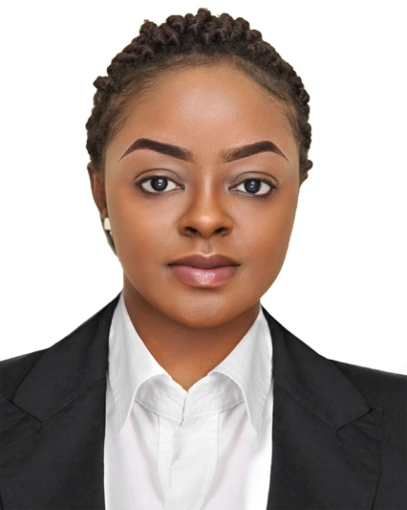
ZITA

Zita-391397@2freemail.com

MAKEUP ARTIST/SALES
OBJECTIVE
Highly dedicated and skilled Makeup Artist with an exceptional record of customer service and client satisfaction. Adept at perceiving individual clients’ unique skin tone and corresponding makeup needs and recommending products accordingly. Able to work well independently or as part of a cosmetology professional team.

AREAS OF EXPERTISE
- Strong familiarity with makeup industry standards
- Obtain excellent customer service skills
- Excellent grasp of cosmetology with regard to makeup application
- High multitasking and organizational abilities
- Exceptional written and oral communication skills
- Build weekly sales acquired knowledge of store products and services
- Handle customer queries and complaints about the products and resolve them
- Provide post sales assistance to the customers and upsell or cross sell as and when required

WORK EXPERIENCE
JUNE 2016 to: DECEMBER 2018
MAKEUP ARTIST/SALES2016 – 2018
NIKI HEAT STUDIO BAMENDA CAMEROON

- Apply makeup to clients using a color palette and different tools such as mascara, sponges, eyebrow shapers, lip liners, brushes, and applicators.
- Work with clients to create various looks.
- Up-to-date on the latest makeup trends.
- Apply makeup for big events including weddings, birthdays, outings.
- Set makeup with hairspray or other setting material.
- Use photographs or models for reference when consulting with clients on ideal look.
- Strong visualization skills.
- Teach makeup application to clients.
- Ensure makeup looks natural and well-applied under different lighting.
- Match skin color to color palettes to determine best looks.
- Maintain awareness of health and safety issues and legislation.

FREELANCE MAKEUP ARTIST ON THE FOLLOWING PROJECTS
BAMENDA FASHION WEEK – CAMEROON 2017
NIKI HEAT STUDIO BAMENDA CAMEROON

- Did makeup for all runway models in Bamenda – North West Province (full makeup and uncountable touch ups with lipstick and eyeshadow change).
- Did makeup for all runway models in Buea – South West Province (full makeup and uncountable touch ups with lipstick and eyeshadow change).

THE BIGUP SHOW (NATIONAL TV) – CAMEROON 2017

- Did makeup for all the speakers on the show which for a period 2months on almost a daily basis.

UJAMS HOSTED IN DOUALA – CAMEROON 2018
- Did makeup for all models – South West Province (full makeup and uncountable touch ups with lipstick and eyeshadow change)

BAMENDA FASHION WEEK – CAMEROON 2017

- Did bridal makeup for bride and bridesmaids at least 4 times monthly during slow periods and up to 20 times a month during peak periods. All of these involved personal negotiation and communication with the clients.
- Makeup for photoshoots, portraits, artistic makeup.
- Did dozens of birthday, outing and party makeup.

EDUCATION
- August 2011, LCC Mankon Northwest Bamenda, Cameroon Advance Level
- August 2009, GBHS Muyuka Southwest, Cameroon
Ordinary Level

LANGUAGE: English –ExcellentFrench–Average
HOBBIES: Swimming, Listening to Music, Travel, Cooking

