**EXPERIENCES/ INVOLVEMENTS**

**WORK EXPERIENCES**

**METROPOLITAN BANK AND TRUST COMPANY (METROBANK)**

**Customer Service Representative- Teller (November 2017- February 2019)**

* Opens new customer accounts and closes existing accounts at customer request.
* Provides customer assistance with balance detail and other inquiries.
* Refers customers to appropriate financial services and products as required.
* Handles all customer complaints and issues with high professional courtesy.
* Assists with sales referrals and cross-selling programs as needed
* Cash checks and pay out money after verifying that signatures are correct, that written and numerical amounts agree, and that accounts have sufficient funds
* Receive checks and cash for deposit, verify amounts, and check accuracy of deposit slips.
* Examine checks for endorsements and to verify other information such as dates, bank names, identification of the persons receiving payments and the legality of the documents.
* Resolve problems or discrepancies concerning customers’ accounts.

**ALDRTZ CORPORATION (ALMANA GROUP OF COMPANIES)**

**HR- Jr. Performance Management & Special Project Specialist**

**(July 2016- October 2017)**

* Pooling, screening and interviewing of applicants for 14 companies.
* Monitoring of Pre-employment requirements of new employees, in charge of initial screening forRank and File, Supervisory and Managerial positions, assisting the Jr. Recruitment Specialist inpooling for Rank and File applicants.
* Conducts performance evaluation to regular employees.
* Makes summary of performance evaluation reports.
* Monitors employees for regularization.
* Processes weekly and monthly payroll reports.
* Processes timekeeping of employees (time-in and time-out, leave credits, tardiness and absences)
* Registers new employees for statutory benefits
* Prepares monthly statutory benefits reports and payments.
* Prepares loan applications of regular employees.
* Acts as liaison officer in processing loan applications, payments, and other statutory benefits concerns.
* Processes recruitment applications.
* Processes new employee’s ATM accounts and other bank related transactions.

**SEMINARS & CONFERENCES ATTENDED**

Basic Life Support, Philippine Red Cross (September 2018)

Psychological Association of the Philippines (PAPJA) Convention (January 2016)

Book Smart is not Enough, Junior People Management Association of the Philippines (JPMAP), University of St. La Salle (January 2015)

The Magic of Play, University of St. La salle (February 2015)

Be a Hero, University of St. La Salle (January 2015)

Psychological Incapacity, University of St. La Salle (2015)

**ORGANIZATIONS & PARTICIPATIONS**

Member, Philippine Red Cross First Aider (2018- Present)

Member, Junior People Management Association of the Philippines (2014-2016)

Member, Psychological Society (2012- 2016)

Intern, St. Joseph School La Salle (2015)

Intern, Pepsi Cola Products Philippines Inc. (2015)

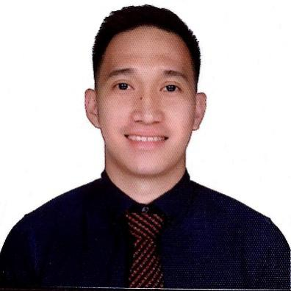

**JAYVEE**

[jayvee-391399@2freemail.com](mailto:jayvee-391399@2freemail.com)

**PROFILE**

Experienced professional in the field of Human Resources and Bank Operations.

**EDUCATIONAL BACKGROUND**

University of St. La Salle- Bacolod

Bachelor of Arts Major in Psychology with certificate in Marketing Management

2012- 2016

**RELEVANT SKILLS**

* Computer Literate
* Proficient in MS Office (Excel, Word, and Power Point)
* Good Oral and Written Communication Skills
* Management and Decision-Making Skills
* Multi- tasking and Flexibility
* Hardworking, Reliable and Responsible
* Can work under pressure
* Can work well in groups and establish rapport with other employees
* Good customer service skills