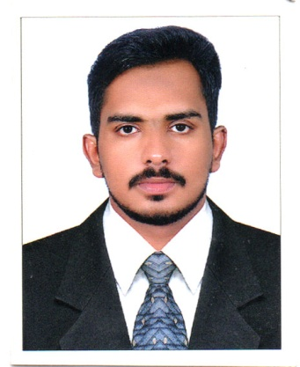
md Sheheen
master of business administration

Sheheen-391410@2freemail.com

OBJECTIVE

To contribute to organization effectiveness through emphasis on efficient utilization of business knowledge, experience and skills while adding value to the organization. I have two years of work experience in marketing department and management area across a diverse range of customers and business domains. I have completed International MBA from Birmingham, United Kingdom. I am currently located in Abu Dhabi, United Arab Emirates on visit visa. I am currently looking for new challenges and responsibilities in Marketing, Sales and Finance Management areas.

KEY SKILLS

- Ability to design business proposal and business plan.
- Proficient in M.S office, word, excel and power point.
- Excellent customer relationship management skill and a good team player.
- Ability to create innovative business idea.
- Good problem-solving skill.
- Excellent time management skill and the ability to prioritize workload.

Work EXPERIENCE
September 2016 to January 2018
British Petroleum
Asst.Store Manager
Birmingham, United Kingdom

- Coach and support other team members.
- Hire and train new employees for the sales floor or other departments.
- Maintain and monitor store inventory.
- Ensure the store is clean, safe and presentable for customers.
- Greet and assist customers as necessary when other sales associates are busy.
- Conduct regular audits of the store’s physical and practical condition to ensure quality.
- Maintain product levels appropriately and generate daily sales report.

January 2018 to January 2019
Hi beryl Exports Pvt.Ltd
Executive Accountant
Kerala
India

- Maintain Bank Balance information
- Maintain petty cash records. .
- Prepare and post monthly records.
- Prepare monthly GST returns and submit to auditor.
- Preparing monthly financial reports.
- Evaluating the financial aspects of business development.
- Preparing regular client reports and attending all client meetings.
- Track and coordinate all activites occurring for each Account.
- Salary information to Accountants and Auditors.
- Providing financial reports to Auditor.
- Assist with mail opening, donations and debtors subscription banking process.
- Assist with pursuing overdue debtors.
- Handling incoming call as required.
- Maintain online banking.

EDUCATION

2016-2017
Master degree- International Master of Business Administration
Birmingham City University
Birmingham
United Kingdom

2013-2016
Bachelor’s degree- Bachelor of Business Administration
SRM University
Chennai
India
2011-2013
Secondary School
Sir Syed English School
Kerala
India

Academic Projects

Major project for Masters

The role of waiters/waitresses in enhancing service quality perception of restaurant customers: A critical
analysis of the case of British customers visiting Indian restaurants in Birmingham, United kingdom.

Major project for under graduation

A study on Customer satisfaction towards Nippon Toyota, an authorized dealer of Toyota Motors, Thrissur, India with special reference to Toyota Innova.

PERSONAL PROFILE

- Reading, Travelling, Cricket and football.
- Languages known: English, Arabic, Malayalam, Hindi and Tamil.
- Cricket team Capitan of college.
- Skills in English and IT skills conducted by the Higher Education Department and the General Education Department, Government of Kerala, India.

