Curriculum vitae 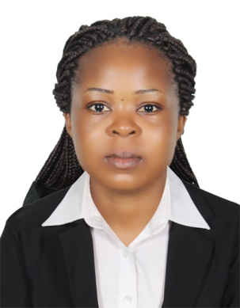
NAME : ANYIFUA
NATIONALITY: CAMEROONIAN
EMAIL : anyifua-391454@2freemail.com
MARITAL STATUS: SINGLE

AN APPLICATION FOR THE POST OF : Cleaning

CAREERS OBJECTIVES:
Seeking a challenging position in a developing organization where my expertise and Experience can be put to the best possible use and my potentials can be effectively tapped. A position that gives me opportunities to developed integrates and applies my knowledge and Skills.

TECHNICAL SKILLS
- Hospitality Management.
- Good communication skills
- Excellent spoken and writing English and fair in French
- Excellent telephone skills
- Microsoft skill especially word and excel
- Team player, professional and fast learn

EMPLOYMENT HISTORY
WAITRESS/ SERVICE STAFF IN CHARIOT HOTEL
KEY RESPONSIBILITIES
- Provide friendly service to guest and associates
- Welcoming and directing guest to their table
- Presenting menu to the guest and help them to explain the various food type in the menu
- Taking care of the buffet by cleaning, refilling juices and cutlery, cleaning plates and placing name tag to the various food in the buffet
- Help guest in making coffee and tea and also cleaning the coffee machine
- Relaying of guest order from the kitchen or bar staff, Inquiring if they have a reservation and noting it in the reservation book if they do
- Check with guest to ensure that they are enjoying their meal and refilled their drinks if they needed
- Remove dishes and glasses from the table or counters and take them to the back
Area/ kitchen for cleaning.
- Maintaining cleanliness and keep the sitting arrangement in order
- Help in setting VIP table and napkin folding
- Help guest in reading the flight board and give them appropriate them for their
next flight, thanking guest for using the lounge and wishing them a pleasant flight.

WAITRESS (KUCHINA RESTAURANT)
RESPONSIBILITIES:
- Explaining how various menu items are prepared, describing ingredients and
Cooking method.
- Prepared table for meals, including setting up items such as linens, silverware and glassware.
- Performed food preparation duties such as preparing appetizers, cold
Dishes and even preparing drinks like cocktail and fruit pouch.
- Escort guest to their table
- Describe and recommend wines to customers

EDUCATIONAL BACKGROUND
- ADVANCED LEVEL CERTIFICATES
- ORDINARY LEVEL CERTIFICATES
LANGUAGE:
ENGLISH: Fluent and perfect in both speaking and writing
FRENCH: Fairly in speaking and writing
HOBBIES: Research, reading and passion in serving.

