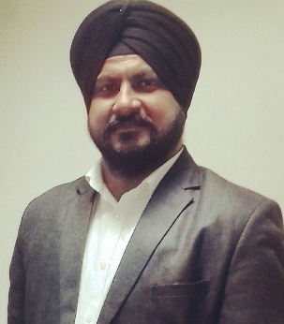

CURRICULAM VITAE

Mandip

Mandip-391456@2freemail.com

OBJECTIVE:
- Professional Objectives :
To give the best of my learning, knowledge , experience and exposure to the
esteemed organization.

- Career Objective :
Seeking a challenging position to utilize my skills & abilities in the field of it
enabled services. I am with hard working , reliable dedicated to duty , highly
flexible to time and demand & can take up multiple roles when required.

WORK EXPERIENCE:

- Working in Axis Bank Ltd as Priority Relationship Manager at Asansol Main
Branch in Manager Grade from April 2019 to till the date

- Working in Axis Securities (Axis Direct) in Broking channel as a Branch Manager at Durgapur Branch from March 2017 to March 2019.

- Worked in HDFC SECURITIES LTD As Branch Manager from March 2013 till March 2017 at Asansol Branch

- Worked in Kotak Securities Ltd at Asansol Branch as Assistant
Manager (Client Servicing& Dealings) from 18-02-2008 till March 2013

- Worked in Narnolia Securities Pvt.Ltd (MotilalOswal Securities Ltd)
As Relationship Manager ( Client Service) from September 2006 to
Febuary 2008

ACHIEVEMENTS:-

          - Qualified in International Destination in SIP kaMarathan.
          - Got Employee of the Quarter award for Oct to Dec 2017 in BM Category.
          - Got Employee of the Quarter award for Jan to March 2018 in BM Category.
          - Got award in October Fest Contest.
          - Got Award in Captain Axis Reactivation Drive.
          - Qualified in every SIP & Reactivation Drives given by management.

ACADEMIC QUALIFICATION :

- Bachelor of Commerce from Burdwan University (W.B) in IInd Division.

- Passed NISM Equity Derivative Series VIII (expired)

- Passed IRDA License

- Passed AMFI (Expired)

COMPUTER SKILL:

- MS-Dos, Window, MS-Office (Word, Excel, Power-Point)
- Tally Graduate. ( Computerised Accounting Package)
- Knowledge of Internet.

EXTRA-QUALIFICATION :

- ‘B’ Certificate in ‘A’ Grade &
- ‘C’ Certificate in ‘B’ Grade in N.C.C from ARMY WING.

EXTRA-CURRICULAR ACTIVITIES:

Took parts in various cultural and Social activities organized by the Govt. & Semi-Govt . Authorities.

ABOUT MYSELF:

I strongly believe in hard work and honesty. I am confident in whatever I do and strive to achieve the best under all circumstances, love to work as a member of team and at the same utilize talents to give the input and synergy.

PERSONAL DETAILS:

Date of Birth : 29th day of September 1982
Sex : Male
Marital Status : Married
Nationality : Indian
Languages Known : Hindi, English, Punjabi, Bengali.
Hobbies : Making friends, Listening Music, Plying Cricket &
Travelling.

