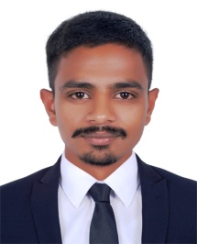
Sumit

skills, professional

Email: sumith.391458@2freemail.com

Career Objective:
Seeking a position in an organization, which provides a challenging environment for my leveraged expertise to be fully utilized, thereby assisting in adding value to the organization and aiding my growth.

Educational Qualifications:
• BE Mechanical Engineering (pursuing degree-Rajiv Gandhi University M.P,India)
• Senior Secondary School Certificate (10+2) from Board of Secondary Education Bhopal M.P.2015 (Year2015)
• High School Certificate (10th) from Board of Secondary Education Bhopal M.P.2013 (Year 2013)

Personal Skills:

• Strong analytical and critical thinking skills.
• Self-driven and motivated to drive improvements across the team
• Eager to learn.
• Quick learner Focused

Computer Skills:

• Diploma in Computer Applications (Maharishi Mahesh Yogi Vedic Vishwavidyalaya – Indore MP)
• Photo/Video Editing Software (Adobe Photoshop) -(Indore institution of Computer Education-Indore MP)
• Training in AutoCAD, Hyper mesh, Creo 3.0 (Indore institution of Computer Education-Indore MP)
• Diploma in mobile repairing (hardware/software) (ISHAPE- Regd. under Govt. of Madhya Pradesh)

Extracurricular Activities

• Participated as a team member in a sports league.
• Worked as a Photographer in “Spandan-Annual cultural fest”.

Personal Details

Date of Birth : 4 April 1997
Gender : Male Nationality : Indian Marital Status : Single
Languages known : English, Hindi
Hobbies : Photography, Playing Musical Instruments

