Contact:
Dolonchampa
Dolonchampa-391501@2freemail.com
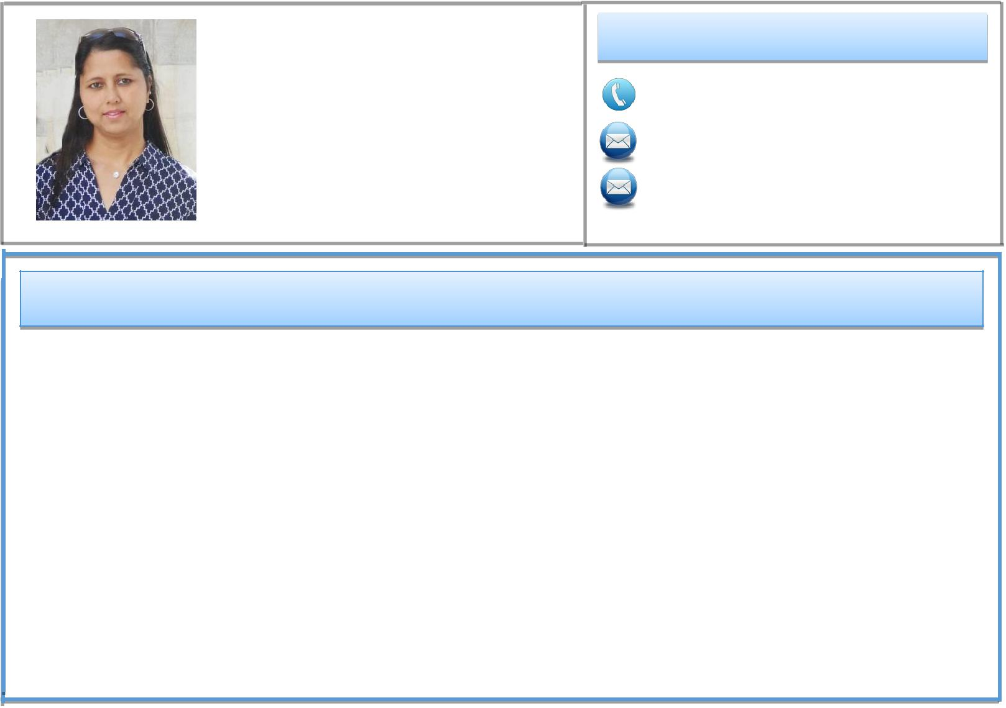

Summary:

- Last two years was working at King Abdullah University of Science and Technoligy, Saudi Arabia as an administrative assistant to the Director.

- Served as an operations manager in a non-profit organization “ORCHI”
- Worked as a ‘Qualitative Data analyst’ in the project ‘Embedding Poor People’s voices in local Governance’.

- Worked as a ‘Research Assistant’ in the project ‘Comparative Electoral Ethnography’. The project conducted a comparative study of Indian elections. It involves ethnographic aspects in 10-15 sites across India.

- Worked as a ‘Research Assistant’ in the project ‘Embedding Poor People’s voices in local Governance’. It is an

ESRC-DFID funded project collaboratively conducted by the University of Sheffield, UK, the Centre for Studies in Social Sciences, Calcutta and the Centre for Development Studies, Trivandrum.
- Worked as a Field Associate in “Safe Drinking Water” project sponsored by Government of India
- Extensive field experience in rural sector
- Self-motivated, detail oriented, hard-working and excellent team member
- Pleasant personality, strong interpersonal communicator with good presentation skills
- Have done research work in various Socio-economic and Development related fields.

Workshop attended:

• Attended a summer school on changing sanitation and Hygiene |  | August 2016
• Joined a symposium on NGO-Government-Corporate effort for social development |  | June2013
• | Training Course on ‘Research Methodology for Social Research’ | February2013
• | Training Course on ‘Geo-informatic Application in Rural Development ’jointly | December 2003

organized by National Institute of Rural Development, Government of India

and State Institute of Panchayats and Rural Development, Government of West Bengal

• Participated in an Orientation Training Programme conducted by
Indian Institute of Public Administration

July 2007

Education:

• Research Training Programme, Centre for Studies in Social Sciences, Calcutta, India. July2007

Research topic: ‘Self Help Group and Microfinance in West Bengal–A critical Assessment’

• Masters in Rural Development and Management, University of Kalyani, West Bengal, India January2006
- Bachelor of Science in Geography (Honours), Vidyasagar College, University of Calcutta, Kolkata, India.

Publications and Awards:

- Ranked first in recycled art competition at King Abdullah University of Science and Technology in April 2016

- Dolonchampa Chakrabarty, Contributions in “WhyPeopleVote?” by Mukulika Banerjee, in “Appendix I, West Bengal”, Routledge Press, 2014.

Papersand Seminars:

- Papersand seminars on the following topics presented as part of fulfillment of the research training programme at CSSSC

- Impact of globalization on rural livelihood.

- Changing land use pattern in West Bengal.

- Influence of television on changing rural India.

- Local democracy, democratic decentralization and rural development.

- SWAJAL DHARA: A CRITIQUE; Performance of a Programme for ensuring safe drinking water to the poor.

- Indian Nationalism-a dream seeking fulfillment.

- Self-help Group and Microfinance in West Bengal – A Critical Assessment.

Papers and Seminars:

- Computer Skills: Diploma in Computer Application: MS Office (Word, Excel, And PowerPoint), Dream Weaver, Photoshop, Map Info (GIS application Software).

- Language Skills: Fluent in English, Bengali, Hindi (Proficient in speaking).

- Completed Diploma Course in Fine Arts from Bangiya Sangeet Parishad, Rabindra Bharati

- Participated in social plays on drug abuse prevention and wildlife protection.

