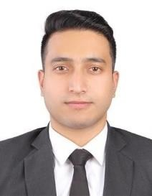

SANGEETH

sangeeth-391522@2freemail.com

Career Objective

Seeking a job opportunity where I may utilize my educational background to learn and deliver as a team player with a sense of responsibility and accountability.

Education & Qualifications

Mechanical Engineering
New Horizon College of Engineering, Bangalore, Karnataka, India June 2014 – June 2018
Final Project: Comparative studies on different parameters for drilling operations on AISI 1045
steel using semi synthetic oil and vegetable oils as cutting fluids

High school
The Indian High School, Dubai, U.A.E Batch of 2014

Work Experience

Summer Internship – 2017
Saleh Bin Lahej Electro-mechanical L.L.C, Dubai, U.A.E.
Was tasked with understanding the practical constraints of theoretical mechanical engineering practices with respect to HVAC systems. Conducted research and presented a report on cooling systems as part of my training.

Certifications and Training

    - Quality Control/Assurance certificate course (3-month course)
    - AutoCAD level 1 certified
    - Attended a training program on ‘Automobile and Vehicle Dynamics’ conducted by ELITE- TECHNO GROUPS

Professional Skills

    - Effective interpersonal and communication skills
    - Driven with a willingness to learn
    - Motivated and goal oriented
    - Able team player
    - Flexible and adaptable to changes

Technical Skills

Microsoft Office: Word, Excel, PowerPoint. AutoCAD 2D, 3D
Catia 3D

Personal Details:

Nationality: Indian
Marital Status: Single
Date of Birth: 16 March 1995
Interests: Football, mixed martial arts, reading & travelling
Language: English, Hindi, Malayalam and basic French & Arabic

