CURRICULAM VITAE
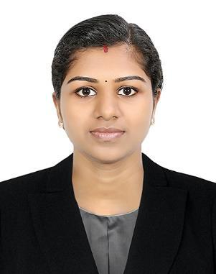

SWATHY

Gmail : swathy-391586@2freemail.com

OBJECTIVE

Seeking a career opportunity with a growing, dynamic organization where I can utilize my skills and abilities for the betterment of company and myself.

EXPERIENCE

- Junior web developer
Konnecty Digital Solutions (1st December 2017 – 30th November 2018)

PROFESSIONAL QUALIFICATION

- Master of Computer Applications degree from Mahatma Gandhi University in November 2017, Kerala

- Bachelor in Computer Application degree from Calicut University in April 2015, Kerala

ACADEMIC QUALIFICATION

- 12th from Sree Krishna Higher Secondary School, Anandapuram(state board) and secured an aggregate of 65% in 2012

- 10th from Sree Krishna High Secondary School, Mattathur, Kerala (state board) and secured an aggregate of 70% in 2010

TECHNICAL SKILLS

Operating system | Windows 10, windows 8, windows 7, windows XP,
 | Linux
Programming language | C, C++, Java, PHP, HTML, CSS, JavaScript
Database | Mysql

Knowledge | Microsoft Word, Microsoft Excel, Power Point
frameworks | Bootstrap
Technologies | Web Development
managerial skills | Front-End Development
Social Media | Google, Twitter, Linkedin, Facebook

ACADEMIC PROJECT

 | Project title |  |  | Mobile Oppertunistic Networks
 | Duration |  |  | June 2017 – November 2017
 | Hardware |  |  | Intel pentium 4, 4GB RAM , 4G Hard disk,
 |  |  |  | Android Phone
 | Operating system |  |  | WINDOWS AND ANDROID
 | Programing language |  |  | Java & Android
 | Database |  |  | SQL Server
PERSONAL DETAILS
Date of Birth |  | : | 30/may/1995
Sex |  | : | Female
Nationality |  | : | Indian
Exp. Date |  | : | 12/08/2028
Visa status |  | : Visiting visa – 3 month
Mother Tongue |  | : | Malayalam
Languages Known |  | : | English, Malayalam

DECLARATION

I hereby declare that all the above information provided is true to the best of my knowledge and belief.

Swathy

