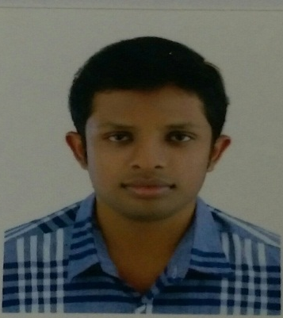
NITHIN

Email: nithin.391592@2freemail.com

CAREER OBJECTIVE

To work in a reputed organization as a mechanical engineer to enhance my practical experience and knowledge gained, so far for the development and enhancement of the company as a bonfire and dedicated employee of the organization

EDUCATION AND CREDENTIAL

❖ Bachelor of Mechanical Engineering
Sri Vellapally Natesan College of Engg, Kerala.
Kerala University.

❖ AISSC Examination - (Science)
St John’s School, Kerala
CBSE Board, India in 2011

Technical Course

- Diploma in HVAC DESIGN & MEP Engineering

ACADEMIC WORKS

- Volunteer, IGNITE 2013, College Tech fest : volunteered as a chief security for auto expo programme. Gained experience in interacting with people from all around the globe.

TRAINING RECEIVED

- In-plant training at Green Wind and solar powertech pvt Ltd,Coimbatore
- Industrial visit at,G B Enginnering Enterprises Trichy, Tamilnadu

Computer Knowlegde

- C++
- CADD, SOLID WORK
- REVIT MEP

Key Skills

- Communication
- Problem Solving
- Team Player
- Planning and organizing
- System Knowledge

PERSONAL VITAE

Date of Birth: 27th Dec, 1992
Languages Known: English, Hindi, Tamil and Malayalam
Father’s Name: K Vijayan
Nationality: Indian
Marital Status: Single

