Anthony
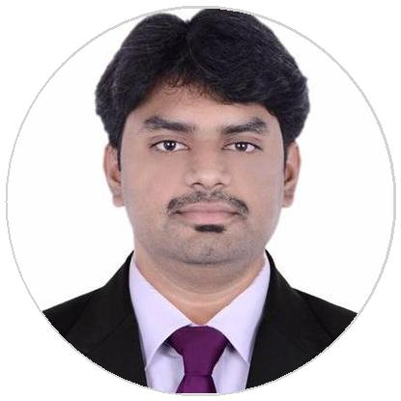

Anthony-391594@2freemail.com

WORK EXPERIENCE

TEAM LEADER (Customer Service Management)
Zoom Car India Private Limited.

01/2014 – 01/2019 Bengaluru, Karnataka, India.

Zoomcar is a self-drive car rental company headquartered in Bangalore, India. The company was founded in 2013 by David Back and Greg Moran. As of February 2017 the Company operates in 27 cities across India.

BRIEF POINTS OF WORK SUMMARY AS A TEAM LEADER FOR FIVE YEARS

Attending calls of self drive cab customers and team leaders and updating availability of Cars in the App and website(during tenure as a fleet executive) contributing to the rentals/sales of company.

Making calls to dealers and service managers to get vehicles serviced/repaired on time and updating the same in the vehicle register.

Attending calls of various emergency alerts of customers such as vehicle accidents by customers and breakdowns.

Coordinating, calling and helping fleet operatives to retrieve the vehicles out of service centers on time.

Calling service advisers and obtaining correct estimations and quotations of the vehicles to be serviced/repaired negotiation of the same and availing huge discounts largely reducing the costs.

Coordinating through calls, transports and transshipment of vehicles between diﬀerent sites/branches.

Driving and delivering new cars to various sites spread across India as and when required by the company.

Updating and sharing service history of vehicles to the company and its sites/branches.

Testing, driving and suggesting the Zoom vehicles condition either to block its usage or suggesting service/maintenance.

Providing daily E-Mail updates to the Chief Operating Oﬃcer of the vehicles worked upon, submitting invoices and obtaining approvals and funds for retrieval of vehicles.

SKILLS

Skilled Driving & Riding

Working Knowledge of Computers & Tabs

Maintaining Accounts, Records & Registers

Communication & Negotiation

Adaptability and Flexibility

Leadership and Management

Collaboration & Team Work

Time Management & Decision Making

Motivating myself & others

Ability to work under pressure

PERSONAL DETAILS

FULL NAME: ANTHONY DILIP RAYAPPA

DATE OF BIRTH: 25th June 1993

NATIONALITY: Indian(Holding valid Indian passport)

AVAILABILITY: Immediately

MARITAL STATUS: Unmarried

PASSPORT DETAILS

PASSPORT NUMBER: P9020255

DATE OF ISSUE: 31/03/2017

DATE OF EXPIRY: 30/03/2027

PLACE OF ISSUE: BENGALURU

VISA STATUS: On Visiting Visa

EDUCATION |  | LANGUAGES
 |  | English | Hindi
Bachelor of Commerce (B.com) |  | Full Professional Proficiency | Limited Working Proficiency
Dr.C.V.Raman University |  | Kannada | Telugu
06/2015 – 06/2018 | Bilaspur, Chattisgarh , India. | Full Professional Proficiency | Full Professional Proficiency
 |  | Tamil
Pre-University Education(P.U.C) |  | Professional Working Proficiency
Harward PU College |  | INTERESTS
06/2009 – 07/2011 | Dasanapura, Bengaluru ,India

Travelling Music Meeting new people

