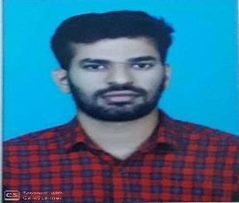

KRISHNAN
EMAIL: - krishnan-391596@2freemail.com

CAREER SUMMARY
To grow in my professional career by taking up challenging roles in the workplace, adding tangible value to the firm and achieve organizational goals by constantly updating new knowledge & technical experience both on and off the job.

ACADEMIC QUALIFICATION
- Completed BE Electronics and Communication at SVS College of Engineering Coimbatore in the year of 2016.
- Completed Diploma in Electronics and Communication at KARPAGAM polytechnic college Coimbatore in the year of 2013.

WORK EXPERIENCE

Computer Sales Coordinator and salesman in Softop Systems in India (June 2016 to October 2017).
- Maintain knowledge of multiple brands.
- Familiar with available Smart phones and computers in market.
- Explain options to customers and recommend best-fit choice.
- Offer accessories and insurance to improve sales.

Worked as a sales executive in Sudheer Construction Company in India (February 2018 to November 2018).
- Maintain the daily sales report.
- Assisted customers in selection of service that best fit for their use.
- Completed customer payments and answered questions

ABILITIES
- Highly motivated and eager to learn new things.
- A good analyst.
- Good team player and positive attitude.
- Ability to produce best result in pressure situation.

COMPUTER SKILLS
- Microsoft office
- Operating system: windows XP, 7, 8,10
- Hardware and Networking

PERSONAL DETAILS
- Date of Birth : 07/June/1992
- Nationality : Indian
- Marital Status : Single
- Languages known : English, Malayalam, Hindi, Tamil.

