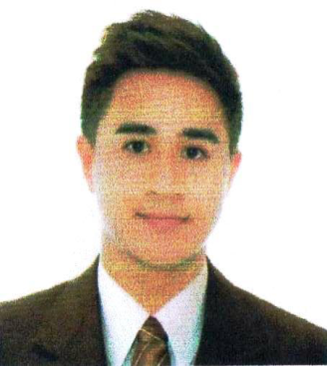

Clark
Sales Executive/Receptionist/Admin Clerk/Waiter
clark-391614@2freemail.com

Service oriented professional with 7 years of total work experience in Customers Service Industry as Sales Consultant/Receptionist/Customer Service/Office Staff. Exposed in all Distribution Channel Hospitality, efficient customer service and to create a warm and welcoming atmosphere for all of our guests, with the key aim of retaining and to maintain relationships with clients. Ability to lead diverse team of professionals and deal with Customer related problems. Proficient with MicrosoftWord,Excel,bankprocedure,carshow,preparingevents,P,O,S transaction,Telemarketing,reservation,dealings viewing units, and other business professional applications.

Strengths
 | Proven hospitality service experience over the phone |  | Excellent time management and organizational skill.
 | Quick learner, Self-Motivated and Determined |  | Guest service and relation building skills, having good interpersonal skills
 | Multi-tasking and ability to work under pressure. |  | Customer Service well-oriented
 | Good leader of multicultural staff |  | Skilled Team Leader / Team player

Education
Bachelor of Science Industrial Education.  Major in Computer  Nueva ecija University of Science Technology  Computer technician (Vocational)  Xavier Technical Training Center Corporation |  | JUNE2007-  March2011  2013Completed

Career Progression
Receptionist,waiter. Diamond Residence.Philippines |  | February 2019 to january 2018
Sales Consultant,Dune London Luxury Brand(StoreSpecialist) Philippines  Athletic Trainer for Men and Women. Nueva Ecija University Science Technology Philippines. |  | 2014 to 2017  2013 to 2014
Sales Consultant, Mens Dept.Faconnable Luxury Brand France (Rustans Commercial Corporation) Phillipines |  | 2012 to 2013

Job Description
RECEPTIONIST/SALES CONSULTANT/ADMIN CLERK/TRAINER

- Strong communication abilities, computer knowledge as well as data entry skills.
- Deal with all enquiries in a professional and courteous manner, in person, on the telephone or via e-mail.
- Preparing reservation research the themes of event, typically using Creativity appearances
- Be involved and contribute at team meetings, Orientation,Seminars.
- Receiving all calls and properly transfers to the appropriate department.
- Creating application form dealings submitted to the bank waiting for approval. Or in house approval.
- Prepares daily report on upselling target and limit the cost.
- Report any maintenance issues immediately to manager on dutyr, including the trainor and heads, fittings and equipment. Maintaining the inventory/filing of all the office stationeries
- Performs basic clerical tasks. Operates standard office equipment.
- Counselling and guidance to employees to ensure that policies and procedures are met.
- Making sure clients meet their needs.
- Excellent in building rapport, asking open-ended question to provide appropriate customer needs.
- Ability to prioritize, planning skills, well-organized, multitasking and assuming responsibilities and duties. Possessing the capacity to cope with failures and trying to learn from past mistakes.
- Expertise in resolving escalated customer service issues, solving all problems quickly, effectively and with empathy.
- Talent for identifying customer needs and presenting appropriate solutions, products, or service offerings to exceptionally satisfy customers
- Demonstrated ability to gain customer trust and provide exceptional follow-up increased sales,updating promo,maintains upselling w/ excellence standard service.
- Proper distribute deliveries in talabat driver doubled check cash, and item to avoid complain & mistakes.
- Daily supervise in all running item, changing level of dates, prepares all requesting needs.follow up pest controller maintaining cleanliness in and out of the house.
- Scheduling and coordinating meetings,interview, event, carshow,and others similar aactivities.

Personal Information
Nationality | : | Filipino
Date of Birth | : | 26th of May
Language | : | English
Visa Status | : | Visit visa

Reference
Upon Request

