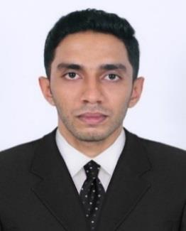
BINIL

“Versatile, high-energy professional CIVIL ENGINEER offering 2 years of dynamic career in

planning and construction of highways and multi - Storeyed buildings of various aspects.

Scaling new heights of success with hard work, dedication and leaving a mark of excellence in

each step”

Binil-391674@2freemail.com

PROFILE SUMMARY

- Civil Engineering graduate with 2 years of comprehensive experience in Planning and Execution of multi-storeyed buildings and highway road construction projects.
- Masters Diploma in Project

Planning Management.
- Certified professional in

Primavera P6 16.1.

- Certified professional in AutoCAD 2018

- Certified professional in

Microsoft Project 2016.
- Technically proficient in

Microsoft office.

- Overall score of 6.0 in IELTS (International English language Testing System)

MAJOR PROJECTS HANDLED

- Supervision, setting out, Piling work, Sub structure and Super structure of a G+4 Apartment Project (LAURA CASA) at Kaloor, Cochin.

- Construction of Highway, RCC Culvert at Kalamassery industrial estate using alternate staggering of U-shaped bars reinforcement.

- Initial Surveying, Leveling and Widening of Connection road (7km) at Mala, Thrissur, Kerala.) {WMM, GSB, BM, BC}

SKILLS EXPERTISE
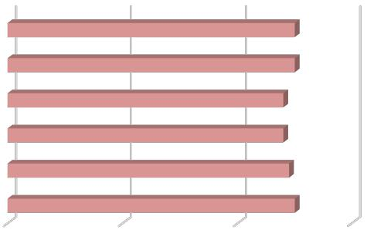

Team Building & Leadership

Supervision

Cost Reduction Analysis

Reporting & Documentation

Planning Management

Site Operations

CAREER EXPERTISE

PROJECT ENGINEER
LAURA VENTURES Pvt. Ltd.

Cochin, Kerala

Duration | - | June 2018 – May 2019
Project | - | LAURA CASA, Kaloor, Cochin.
 |  | Ground + 4 Storeyed Residential
 |  | Apartment
Budget | - | 3 Crore Indian rupees

SITE ENGINEER
MARYSADAN EDATHALA Pvt.

Ltd. Cochin, Kerala

Duration | - | June 2017 – May 2018
Project | - | Construction of New Highways (Including
 |  | Culverts and pedestrian ways, WMM &
 |  | GSB) and renovation of existing
 |  | pavements (BM, BC) for Kerala Public Work
 |  | Department (PWD)
Budget | - | 10 Crore Indian rupees | Page 01 / 03

EXPERIENCE SUMMARY

Project Engineer

June 2018 – May 2019

Laura ventures Pvt. Ltd.

Cochin, Kerala, India.

- Ground + 4 storeyed residential apartment project costs more than 3 Crore Indian Rupees.

- Support the site Construction and Projects Manager in the management of the civil and other related works at the site.

- Prepare, schedule, coordinate and monitor the assigned engineering projects.

- Conduct Risk analysis for each project.

- Participated in project marketing, work planning, scope development and fee estimating

- Provided cross-discipline deliverables such as calculations, design changes, and drawing revisions.

- Worked on take-offs and estimation. Prepared and maintained schedules.

- Worked on Cost control, budgeting, bidding and document control. Coordinated between different trades.

- With supervision and guidance, plans and conducts work requiring independent evaluation, selection and substantial adaptation/ modification of standard techniques, procedures and criteria.

- Verification of all Subcontractor earth works and civil works quantities for progress claims.

Site Engineer

June 2017 – May 2018

Marysadan Edathala International Pvt. Ltd.

Cochin, Kerala, India.

- Multiple construction projects for State Public work Department including construction of new Highway, WMM, GSB, and renovation of existing pavement (BM, BC) through different regions of Ernakulam district.

- Remained on-site to ensure that all work was carried out according to specifications.

- Assign responsibilities and mentor project team.

- Confirmed that all engineering designs conformed to highway design specifications.

- Worked with project manager to develop designs that met budget guidelines.

- Measured the quantity of material used by contractors for billing purposes.

- Performed evaluation and conditional survey of existing pavement and design and rehabilitation of pavement as required.

- Manage the repair and maintenance of completed projects.

- Communicated important verbal and written duties between NHAI supervisors and PWD supervisors

Page 02 / 03

EDUCATIONAL QUALIFICATIONS

4 Yrs. |  | B.Tech |  |  | Civil Engineering |  |  | 7.01 CGPA
2017 | Baselios Thomas I Catholicose College of |  |  | Mahatma Gandhi University |  |  | Koothattukulam, Kerala
 | Engineering and Technology

2 Yrs. |  | Plus Two |  |  | PCM |  | 77.3 % Aggregate
2013 | S N D P V H S S |  |  | Vocational Higher Secondary |  |  | Adimaly, Kerala
 |  |  |  | Education Board, Kerala

 |  | 10th Class |  |  | S S L C |  | 80 % Aggregate
2011 | S N D P H S S |  |  | Kerala State Board |  |  | Adimaly, Kerala

 |  |  | Personal Profile
 | Date of Birth |  |  |  | 4-Aug-95
 | Gender |  |  |  | Male
 | Marital status |  |  |  | Single
 | Religion |  |  |  | Christian
 | Nationality |  |  |  | Indian
 |  | Language Proficiency |  |  |  |  |  |  |  |  |  |  |  |  |  |  |  |  |  |  |  | Certifications
 | English ( R, W, S ) |  |  |  |  |  |  |  |  |  |  |  |  |  |  |  |  |  |  | Primavera P6 16.1
 | Hindi ( R, W, S ) |  |  |  |  |  |  |  |  |  |  |  |  |  |  |  |  |  |  | AutoCAD 2018
 | Malayalam ( R, W, S ) |  |  |  |  |  |  |  |  |  |  |  |  |  |  |  |  |  |  | Microsoft Project 2016

Page 03 / 03

