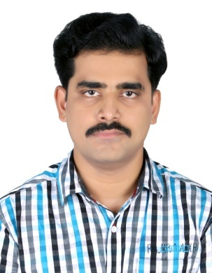

BASTIN

Email: bastin.391692@2freemail.com

OBJECTIVE
Seeking a position that enables use of my education, skills, individuality and resilience and also gives the opportunity to glow professionally.
PERSONAL PROFILE
Nationality : Indian
Sex : Male
Age : 31
Date of Birth : 29th September 1987
Place of birth : Thrissur
Marital Status : Single
Religion : Christian, Roman Catholic
Language Known : English (Read, Write & Speak) Malayalam (Read, Write & Speak)
Hindi (Read, Write & Speak)
Arabic(speak)
EDUCATION QUALIFICATION
1. S.S.L.C (Government of Kerala) in 2005
2. Diploma in Fire and Safety Engineering (NIFE) in 2009
WORK EXPERIENCE
- Working as sales man, Dubai. (From July 2015 till now)
- Worked as Cashier & Salesman at MEED HOLDING COMPANY (Supermarket),
Riyadh, Kingdom of Saudi Arabia for 33/4 years (From September 2010 to
June 2014).
- Worked as Salesman at HOME PLUS, Thrissur for 1 year (From August
2009 to July 2010).
- Worked as Cashier & Salesman at ELITE SUPERMARKET, Thrissur for 2
years (From June 2006 to April 2008).

