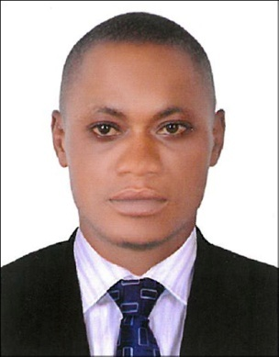
SANUSI
Email Id: sanusi-391772@2freemail.com

GENERAL HELPER

CAREER OBJECTIVE

To work for an organization which provides me the opportunity to improve my skills and knowledge to growth along with the organization objective.

SKILLS

- Excellent communication and interpersonal skills.
- Positive attitude, confident & strong personality.
- Willingness to work effectively and efficiency.
- Ability to climb at least two flight of stairs
- Ability to lift heavy objects
- Able to knee, bend or reach above the shoulder

WORK EXPERIENCE

Position : GENERAL HELPER
Company : Premier Hotel Ibadan Oyo State, Nigeria
Year : 2017-2019

Position : GENERAL HELPER
Company : Yetkem Pharmacy, Nigeria
Year : 2014-2017

Position : GENERAL HELPER
Company : Lagos International Airport (Cargo Terminal), Nigeria
Year : 2010-2014

Duties & Responsibilities
- Administered and provided assistance to everyday processes.
- Administered various shop activities and provided assistance.
- Monitored general activities of operations and provided assistance as per requirement.
- Clean and maintain work areas
- Carry supplies to work area

EDUCATIONAL QUALIFICATIONS

Primary School Leaving Certificate
West Africa Examination Certificate

Language Known : English

PERSONAL DETAILS

Date of Birth : 5th April 1992
Gender : Male
Marital Status : Single
Religion : Muslim
Nationality : Nigerian
Visa Status : Visit Visa

Hobby
Love reading, Football, Running and Basketball

Reference
Available on Request

I hereby declare that all the information mentioned above is true to the best of my knowledge and belief.

SANUSI

