CHRISTOPHER
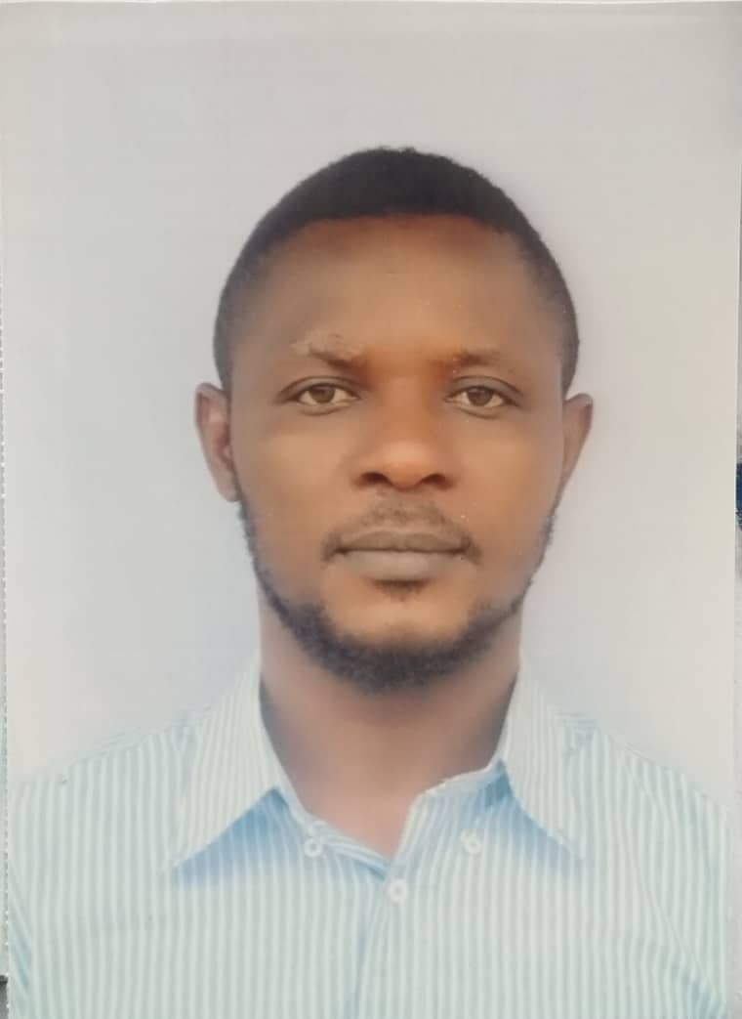
- Physical Therapist
- Male (Single; Nigerian)
- Date of Birth: 29th April, 1991
- E-mail: isinetugo-391805@gulfjobseeker.com
OBJECTIVE
A diligent, energetic, hardworking and multi-skilled physiotherapist with vast potentials and willingness to learn and contribute to quality health care; through lifelong hard-work, researches, learning, perseverance and self-responsibility to personal and professional development.
PROFESSINAL WORK EXPERIENCES
- MEDICAL CENTRE, YENAGOA NIGERIA APRIL 2018 - APRIL 2019
(Under one year compulsory National Youth Service: NYSC)

- USMANU DANFODIYO UNIVERSITY TEACHING HOSPITAL SOKOTO APRIL 2017 - APRIL 2018
(One year internship program under supervision)
Job Responsibilities:
- Examination and diagnosing sick and injured patients (in pains or with disabling medical conditions) on their ailments and then planning appropriate treatments for them; in doing so, taking cultural and social sensitivities into consideration
- Studying the past medical history of a patient to ensure they have no allergies or contraindication.
- Giving appropriate health education and advice to patients especially on the resulting condition to enable self-management.
- Executing the planned treatment towards achieving both short and long term goals at the ideal term.
- Devising and discussing various treatment options extensively with patients.
- Educating/Advising patients on health matters for preventive measures.
- Maintaining accurate medical records and documentation of patient’s case history in details.
- Referring patients to hospitals or specialist clinics for further investigation (If necessary).
- Reviewing tests/scan results to identify any abnormality.
- Ensuring a safe work environment for the patients and staff.
- Supervising other administrative and junior healthcare staff.

EDUCATION
2011-2016 Nnamdi Azikiwe University, Awka Anambra state.
Bachelor in Medical Rehabilitation (BMR) Physiotherapy major
2003-2009 Our Lady’s Comprehensive Secondary School, Nkpor-uno, Anambra state.
West African Senior School Certificate Examination (WASSCE)
1996-2003 Awada Primary School, Awada Obosi, Anambra state.
First School Leaving Certificate (FSLC).

PROFESSIONAL MEMBERSHIP
Member, Nigerian Society of Physiotherapist (NSP)
RESEARCH WORK (PROJECT):
Topic: Physical activity, Psychological functioning (cognition, anxiety and depression), quality of life and seizure severity among people with epilepsy in a Nigerian population.
PERSONAL ATTRIBUTES
- Good communication skills and fluency in English
- Computer proficiency in internet applications, Microsoft offices (word, excel and power point), and a good knowledge of SPSS.
- Experienced in leadership and event organization roles.
- Ability to plan, conduct or coordinate a community outreach.
- Strict safety precaution approach in patient management.
- A good team worker in regards to patient care and rehabilitation.
INTEREST AND ACTIVITIES
Reading, Sports, Music and Travelling
REFEREES:

Will be provided on request

