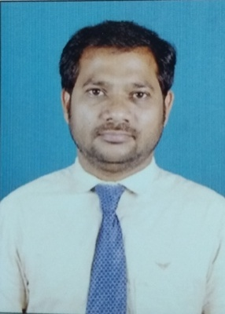
CERTIFIED MEDICAL CODER-CPC

HAJAMYDEEN

Email : hajamydeen-391832@2freemail.com

Objective

Looking for a medical coder job in a healthcare industry where my skills and knowledge can be utilized to the fullest and can be able to serve the people.

SUMMARY OF QUALIFICATIONS
- Certified professional coder from AAPC (Passed on Mar-2019)
- References used for coding includes International Classification of Diseases (ICD-10CM),Current Procedural Terminology (CPT); Health Care Common Procedure Coding System (HCPCS)
- Knowledge of medical terminology, anatomy and physiology
- Key skills: strong communication

Educational Qualifications

- Master of Science (Chemistry) (2001-2003) from Bharathithasan University Trichy, First Class with 74%.
- Bachelor of Science (Chemistry) (1998-2001) from Manonmaniam Sundarnar University Tirunelveli. First Class with 67%.Allied Zoology.

Work Experience:

- Worked as a Medical coder in Intelent Global service Pvt Ltd Chennai from Mar 2017 to Dec-2018 (1 year 9 months).
Job responsibilities:
Review patient medical record assign correct codes.
Maintaining the quality standard.
Attending meeting regarding coding updates.
Follow up the regular client updates.
- Worked as an cashier supervisor in Jarir book store Qatar.from 2011 to
2016.
- Worked as a Plant Supervisor Assistant at East West Exports from July’03 to Feb’06 Chennai.

Technical Skills
Software Skill : Ms-Office (word,excel,powerpoint)

Extra Curriculum Activities:

National Service Scheme (Khadir Mohideen College, Adirampattinam).

Interest
Making Crafts

Personal Details:

Date of birth : 31/05/1981
Gender . : Male
Marital Status : Married
Nationality : Indian
Languages : English, Tamil & Malayalam

