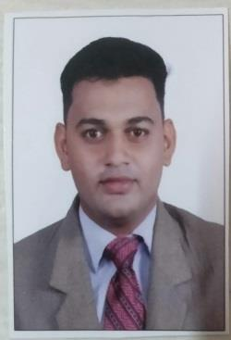
RESUME

Email: akshay.391852@2freemail.com

PERSONAL DETAILS

- Name : AKSHAY
• | Date of Birth | : 01.04.1993
• | Gender | : Male

OBJECTIVE

Looking for a challenging career which demands the best of my professional ability in terms of technical skills and helps me in gaining knowledge.

EDUCATIONAL QUALIFICATION

Exam | College | Percentage | Year Of | Class / grade
 |  |  | passing
B.E |  | 66.53% | 2016 | First class with
 |  |  |  | Distinction
T.E | Imperial College of | 52.53% | 2015 | Second class
 | Engineering and research,
S.E | Pune | 53.13% | 2013 | Second class
F.E |  | 50.53% | 2012 | Second class
H.S.C | J.S.M. College, Alibag | 68% | 2011 | First class

Page 1 of 2

S.S.C | St. Mary’s Convent | 71% | 2009 | First class
 | School, Alibag

COMPUTER SKILLS

- MS PROJECT
- Computer Aided Project Management ( Proficiency in Prima Vera)
- Quantity Surveying (Course from Autodesk Authorized Training Center)
- Computer Aided Structural Analysis and Design (Proficiency in STAAD.Pro)

LANGUAGES KNOWN

- English, Marathi, Hindi.

EXPIRENCE

- One year experience as Jr Engineer at Rugani Property Developer (1/9/2016 TO 30/9/2017)

- Worked at J.M.Mhatre Infra Pvt. Ltd. as Jr.Engineer (14/11/17 TO 30/3/19)

PROJECT WORKS

Topic: Conversion of Sewage Water to Usable Water by applying Phytoremediation with Filtration.(B.E. Project)
Guide: Prof. N. S. Baghele

- Study on Application of Water Hyacinth for Bioremediation of waste water and its verification using related parameters.

EXTRA-CURICULLAR ACTIVITIES

- Participated in ‘Bridge-II’ event at Techno-Cultural event(2013) at VIIT, Pune
- Participated in ‘C-ON Test’ technical event at P.E.S. modern College of Engg. Pune

HOBBIES

- Playing Football and Chess

