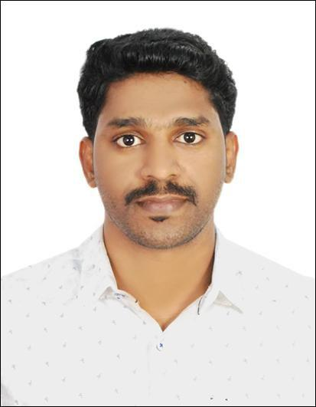

SAMJITH

Samjith-391950@2freemail.com

Profession: Biomedical Technician

PROFESSIONAL PROFILE:

​Biomedical Technician with more 7 years of healthcare work experience in management and service applications of the Medical and Dental equipment’s​. During the work period attained high proficiency in managing the different biomedical equipments, providing on time maintenance as well as service support and training sessions for the operators of the concerned departments.

ACADEMIC PROFILE:

- Diploma in Biomedical Engineering (KMCT Polytechnic College ,Calicut) (2008-2011)

- 10+2​th ​(Kerala state) with an aggregate of 62% from MVM Residential Higher Sec. School Valayamkulam, Kerala (2006-2008)

● | th ​ | ​with 72% from PCN GHSS Mookkuthala, Kerala (2006)
 | 10​ (Kerala state)

PROFESSIONAL EXPERIENCE:

Since September 2015 working as BIOMEDICAL TECHNICIAN under AL REEM HOSPICO COMPANY in following projects

______________________________________________________________________ - 1 -

- ZAYED HIGHER ORGANISATION AL AIN​,since Sept2015 to June 2016,

- AHS PROJECTS ABUDHABI​, since June 2016 .

AMRITA INSTITUTE OF MEDICAL SCIENCES AND RESEARCH CENTER, COCHIN

as BIOMEDICAL TECHNICIAN from July 2011 to September 2015.

Responsibilities Honed​:

- Manage clinical trials for medical products and devices that are helpful to patients.
- Had worked with highly trained Doctors and Engineers.

- Job included Testing, Installation, Calibration and Maintenance of medical equipments.

- Managing and testing including field testing of clinical equipment and medical devices.

- Performed regularly scheduled calibration and preventive maintenance work on patient care systems in assigned departments and keeping of accurate records of time and materials used in the performance during these duties.

- Responded to breakdown calls from various departments.

- Had given equipment training to nurses and doctors.

- Attained good exposure on the evaluation of Maintenance Contract and Electronic Insurance Policy post warranty period of medical equipments.

- Gained experience in the documentation work pertaining to the Electronic insurance policy, uptime calculation.

TRAINING​S UNDERGONE​:

ATTENDED TECHNICAL SERVICE TRAINING FOR NSK HEADPIECES

ATTENDED TECHNICAL TRAINING FOR DENTAL CHAIR ORTHOPHOS XG5/VARIO DG/C8+ ATTENDED TECHNICAL TRAINING FOR DENTAL CHAIR ANTHOS A7 PLUS ATTENDED TECHNICAL TRAINING FOR GETINGE-STERILIZER MODEL NO.533HC

USED CALIBRATION EQUIPMENTS:

Having experience in the usage of Electrical safety analyzer (Fluke, Rigel) , Autoclave temperature and pressure Data logger(OMEGA), Defibrillator​​analyzer, NIBP analyzer,

______________________________________________________________________ - 2 -

ECG stimulator, Digital electro surgery analyzer, Pulse Oxymeter analyzer, KVP meter Ventilator analyzer, Oxygen analyzer, Digital Tachometer etc. .

PERSONAL DETAILS:

Date of birth : 20-06-1989

Nationality : Indian

Driving license : UAE Driving license, Indian Driving licence

