Rehman

DEWA /ADNOC BOROUGE APPROVED Sr.HSE Lead

Expertise in Leading HSE Role,HSE compliance, operational risk management, Drilling & Exploration,Proces safety, EPC, training & development, Audits & inspection, behaviour based program and EHS Campaign with knowledge of development of standards, policies & procedures, manual and check-list as per EHS International Standards.

rahman-392047@2freemail.com
Profile Summary

HSE Specialist & HSE Lead more than 10 years of experience across Up Stream Oil Rig Operation, Down Stream Refinery, Petrochemical, EPC, PMC, Gas Plants, Power & Generation.

Highly accomplished HSE specialist in HSE compliance, Training & development, project management, operational risk management & formulation of strategies as well as policies & procedures. Aptitude to accomplish complex HSE Design

- programs, addresses project compliance, risk assessment, deliver leadership, design & implement new working practices & improve Monitor and advise for implementation of Company Integrated Management System (IMS),ISO-14001 requirements,ISO-45001 requirements, Site EIA / EMP, and Site-Specific HSE Audits & Gap Analysis.

Demonstrated leadership and success with specialised knowledge and experience in managing challenges

Expertise in conducting HSE inspections, emergency drills & risk assessment as well as implementing the Health Safety Environment Management System through evolvement of HSE plans and safe operating procedures for various projects

Professional & qualified “ Trainer as well” and demonstrated my expertise in different levels.
Approved:

- DEWA Dubai Senior HSE Lead for Al Aweer Power Plant Extension Phase IV Project o Pakistan Petroleum, Sr. HSE Engineer in Drilling & Exploration

o ADNOC Borouge, HSE Lead Engineer & approved HSE Trainer as well accomplished “35000” Training Hours for Borouge B2-TA-2018

Core Competencies

HSE Standards & Operations

Team management & Leadership HSE Planning & Compliance

Training & Development Internal Audit Management

Hazard Analysis& Risk

Management

Training & Development

HSE Inspection & Administration

Incident Investigation & Awareness

Soft Skills

Change Agent

Communicator

Collaborator

Motivator

Notable Accomplishments Across the Career

Executed projects on:
- Borouge1 & Borouge B2 TA 2017-2018 without any LTI
- HSE Close-out of B1 & B2 TA-2018 project with 100% HSE Close out

Report to Borouge
Acted as H2S Specialist in H2S Zones & coached the employees on drilling &exploration trainings

Achieved 1.21 safe million hours during last B2 TA-2018 for Descon Engineering & ADNOC Borouge

Implemented the use of self-contained breathing apparatus (SCBA) at H2S zones & coached employees on effective usage of same in H2S zones Worked as HSE Auditor &Inspector in drilling &exploration

Performed risk assessment of ADNOC Borouge B1 & B2 Turn Around including 180 Meters Flare Tip Replacement, Sea Water Basin Chamber Containing Hydrocarbons, Polypropylene Unit Heat Exchangers Bundle Pulling TEAL Lines Valve Replacement

Investigated“16 Near misses during turn around 2 Major LTI'S in drilling & exploration along with 1 massive kitchen fire with proper corrective and

preventive measures such as Fire risk management plan, driver’s operator’s awareness training & restrictions

Successfully managed system certification audits, advancement assessment

audits, gap analysis audits, assurance audits and re- certification audits for Descon Ruwais & Borouge TA B1 & B2, Drilling & Exploration of Wells, projects and so on.

Organizational Experience

Jul’18 – May 2019 “EPC”

ESC/ Siemens - DEWA Al Aweer Power Plant, Dubai as Sr. HSE Instructor

Key Result Areas:

Assisting in development of standardized TRA’S, project specific safety plans (PSSP), Procedures & conduct weekly safety meetings with all Engineers & Supervisors to instruct them on project safety practices and requirements ( DEWA HSEMS, procedures & Local legislations).

Monitoring, identifying & evaluating hazardous conditions and practices and developing policies.

Assist HSE Manager for Procurement of HSE & emergency equipments.

Career Timeline

Since – 2018

Sr. HSE Lead for ESC/ Siemens

2017-2018

HSE Lead with Descon Engineering for ADNOC Borouge TA 1 & TA B2

2011-2017

RIG Operation HSE Engineer for CNPC Drilling Company

2008-2010
QHSE Junior Officer/ Trainee

Design & development of HSE Training Booklet, HSE Signs, banners &posters
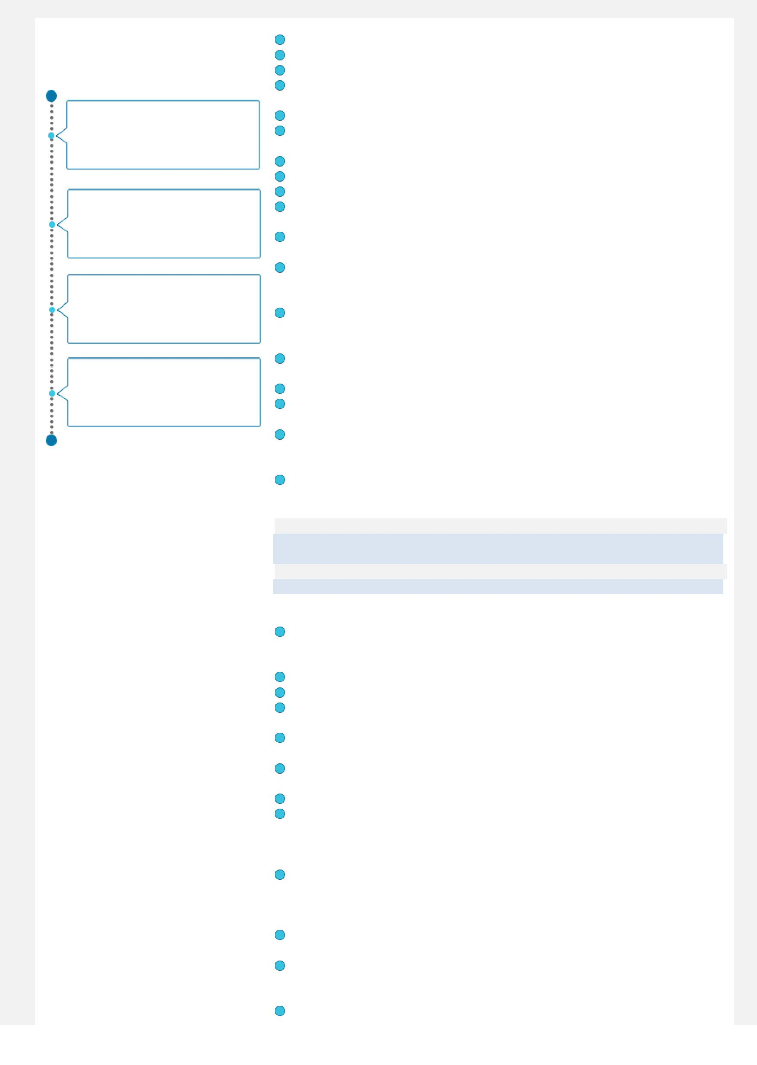
Developing HSE Training procedure, Training Matrix &training plan
Participating in DEWA Project risk assessments.
Participating in weekly walk downs, HSE Management meetings & delivering Tool box in Safety stand downs.

Conducting Sub contracts HSE Audits based on internal & DEWA HSEMS. Analysing related hazard & preventive measures as per client safety

procedures along with electrical, fuel& chemical hazards.
Responsible for conducting HSE Awareness programs.
Responsible for organising “external trainings related to the project. Responsible for participating in client, Sub contractors HSE Meetings. Documenting all incidents/ accidents & near misses, safety violations, unsafe conditions or behaviour using (trend analysis)

Implementing safety plans entailing identification of opportunities, analysis of data, cost benefit analysis, implementation & post audits

Introducing safety management systems both within the organisation as well as at sub-contractors sites enabling them to comply with EHS requirements

Conducting accident/ incident investigation, reporting and facilitation of root cause analysis to prevent recurrence and maintain zero accident/ incident goal

Performing safety inspections / audits, occupational health surveys, surveillance and field auditing for compliance

Responsible for conducting Emergency response trainings & drills. Developing contractor safety management guidelines and number of safety motivational/ training programs for improved safety culture in project. Determining the nature of hazards & instructed action plans in event of any emergency or fire/ gas detection and also suggested necessary measures for the better conditions of the work environment

Delivering trainings, HSE Awareness programs, high risk based activities Tool box, site specific hazards.

Jan’-17- Apr’18: Descon Engineering Abu Dhabi, UAE as HSE Lead & Instructor

( Descon-Ruwais)

Client ADNOC Borouge (Petrochemicals) Project 1544 Borouge 1 & 2 Turn Around

Role:

Assist HSE Manager for developing “HSE Plan” along with relevant Turn around related to plant shut down activities. (e, g PPE’S Matrix, Approval of PPE’S, HSE Equipment’s etc.)

Assigning the “Specific numbering” of Approved TRA’S Pre-qualification & approval process for HSE personnel and mobilization. Inspection clearance and approval of all pre-mobilization of equipment planned in order to get facilitate the operation smoothly.

Selection, Inspection, mobilization of Critical HSE Equipment’s, (Fire extinguishers, gas testers, continuous gas monitoring system, SCBA etc.). Developing specific TRA’S & participating in the “Task risk assessment meetings for approvals.

Development of “HSE Campaigns.

Monitoring of High risk activities ( e.g 180 Meter flare replacement, cleaning of sea water basin, Removal of shell, bundle pulling, Removal & Hydro jetting &cleaning of high risk sludge containing hydrocarbons, H2S, cleaning of TEAL Lines etc)

Assist in the administration of the Management program which includes, but is not limited to get approvals, updating of HSE Organization chart & coordination of training of personnel on changes, updating of Safety Information via HSE Bulletins/ flyers & Site Notes.

Participate in the facilitation, administration, and documentation of Pre Start-Up Safety Reviews or (PSSR).

Development of HSE trainings prior to mobilization with Training Matrix. Such as HSE induction E-PTW, use of critical HSE equipment, Emergency response, fire watch, confined space.

Assigning of HSE Personnel’s at site during Plant Shutdown/plant start- up with peak manpower 3500 nos, involved for the scope for the followings:

Previous Experience

Projects Managed Drilling Wells

Trainings /Certifications

- Ethylene Unit,
- Polyethylene unit,

- Utilities and Sea water basin, o Olefin Conversion unit,

o Flare tips replacement 180-meter height,

o Refurbishing and cleaning of 18 Inch and 30-inch LP/HP flare pipe lines,

o Polypropylene unit-1 & 2

Assist with Client in Plant emergency drills of various scenarios accidental Hydrocarbon release, Fire & medical evacuation. Etc.
Conduct regular site safety walk down, safety inspections /audit etc.
Daily/ weekly/ monthly HSE Reporting’s to internal & client.

Successful submission of Internal & Borouge HSE Audit closes out reports. Oct’10 – Dec-16

CNPC Drilling Company, Pakistan “ RIG HSE Engineer Client: Pakistan Petroleum, (PPL, UEPL, OGDCL)||
Projects/ Wells: HTHP, Wild cats, Exploration, development & workovers wells.

Role:
Implemented health and safety management systems:OHSAS 18001,2007, ISO 4000, EMS 4001 & Client HSEMS System.

Assist in Approval of external international inspections such as Mod Spec and as per IADC requirement.

Responsible for conducting site surveys related to HSE& site security before rig mobilisation.

Assist Rig Manager / OIM for safe rig mobilisation.
Responsible for submission of “Pre Spud safety checklists.

Responsible for submission of close out External audits reports during calendar year 2013, 2014, 2015& 2016 in drilling operations projects
HSE inspection for rigs based inspection criteria’s.
Responsible for HSE Observation & Intervention logs.

Preparation & submission of daily, weekly & monthly reports to client as well as internal management.

Conducting Site emergency drills & conducting employee’s awareness trainings.

Develop HSE Training matrix for all staff.
Well site Risk assessments, drop objects survey, environment related development plan & submission of monthly/ quarterly reports.

Internal safety audits, camp, clinic, emergency equipment’s audit & inspections.

Evaluate standard maintenance and inspection procedures on the rig to identify compliance with safe working practices and industry standards

Reports to Rig manager, HSE Manager, Company man for HSEMS implementation at site.

Participating in daily operational meeting & conducting tool box talks. Accident – Incident, Near miss investigation & awareness to personnel at site.

Collaborated with 3rdparty for H2S Protection/ Prevention system on site Led inspection of SCBA’S, fixed detectors

Feb’08 – Jul’10
Attock Refinery Limited, Pakistan / Apprenticeship

Dubai Electric DEWA Al Aweer Power Plant EPC
Oil Rig Operation Onshore Land Rigs
LNG ,SNGPL “PMC”

Turn Around Petrochemical Plant Borouge
Attock Refinery Ltd., Reformer, NDU,HCU-1
(HTHP Wells), Sui Gas field, Sui Block Well 98, 94 & 100 Barkhan Exploratory Wells, Adhi Field PPL/Adhi Wells, 18,19,21,23 Wild Cats and Exploratory Blocks

Training &Certification in ERT Emergency Response Team Lead (UAE Civil Defence & NAFCO)

OHSAS 18001 ISO 45001 & ISO EMS 14001

HSE MS fundamentals course Loss Prevention Course, 2016 Basic First Aid course (Safety Zone Abu Dhabi 2016,2018,2019)

Academic Details

IRC Certification (Institute of Disaster Management Course,2017) IDRL-Introduction to International Disaster Response Laws, Rules & Principles (English) International Federation of Red Cross & Red Crescent Societies

Life Saver CPR International Federation of Red Cross & Red crescent Societies

Volunteering Red Cross and Red Crescent Induction Course (English) IFRCS BOSIET valid (2016)

H2S field Level II (RUTLEDGE)
Fire fighting (July 2010,2012,2014,2016,2018)
Environment (National Cleaner and Production) Dec’14

Stepping, Handling & Lifting (year course attended 2010, 2012, 2013

Fall Protection (year course attended 2010,2011,2013)
Borouge E-Permit to Work (Session course attended, 2018)
Hydrogen Sulfide Safety (year course attended 2013,2014)

Hazard Observation (HOC) (year course attended 2011)

HAZOP Awareness (year course attended 2012, 2013) International Certification in Fuels: U.A.E (ASTM): Certified body of American Society for Testing and Materials (ASTM), U.A.E Sharjah: 2010

Pursuing NEBOSH-International Diploma in Occupational Health and Safety: Diploma in HSE Engineering from IQRA Institute, Pakistan in 2016 Bachelors (BSC) from University of Gujrat, Pakistan in 2014

Diploma in Petroleum Engineering from IQRA Institute, Pakistan in 2009

Professional Qualifications:
OHS HSE Manager Course 2019.
OSHA HSE Manager Approval

Red Cross Disaster Management Course 2017
National Environment Protection Course NCPC ARL (2014)
NEBOSH-International General Certificate in Occupational Health & Safety:2011

3rdParty Certifications on “HSEMS”

