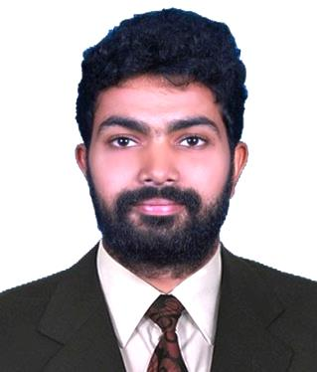
ASWIN
Mail id: Aswin-392052@2freemail.com

CAREER SUMMARY
- Bachelor Degree in Electrical and Electronics Engineering.
- Completed a Safety based certification course named NEBOSH.
- Two-year professional experience as an operation executive.
- Having professional knowledge and experience in Engineering Designing.
- Domestic electrical and electronics working experience.
EDUCATIONAL QUALIFICATION
- Bachelor of Technology in Electrical and Electronics Engineering
Under Calicut University in India on 2012-16
- NEBOSH
IIFS
- Higher Secondary Education (HSE)
Under CBSE in India on 20011-12
- Secondary Education
Under CBSE in India till 2010

PROFESSIONAL EXPERIENCE SUMMARY
Designation: Operation Executive [Jul 2016- Nov 2018]
Company: TCS ION Ernakulum-India

Worked as part of the company and did all the duties and responsibility they gave with all my sincerity.
Duties and Responsibilities:-
- The main duty is to conduct online Examinations.
- Implementing new updates of software and hardware in the client platform.
- Configuring of IP pools using DHCP.
- Network and Power audits.
- Training of the associates related to the particular examinations.
- Team Management and coordination.
- Responsible for the complete examination going on in a particular centre.
- Promotion of the software introduced by the company.

SKILLS
- Electrical and Electronics workings and designing.
- 3D CAD.
- Good in documentation using Microsoft Word, Excel, Power point.
- Event Co-coordinator.
- Resourceful and Creative.
- Ability to take personal responsibility
- Problem Solving.
- Hardware and Networking.
INTERNSHIP AND WORKSHOPS ATTENDED
- Attended an Industrial Visit to Kwality Photonics, Hyderabad in 2014 for LED making and PCB design.
- Attended a workshop on PIC microchip programming and burning conducted by Emprise Technologies in 2014.
ACADEMIC PROJECTS AND SEMINAR
- Mini Project: Sun Tracking Solar Panel by LDR.
- Main Project: Vehicle anti-theft system using solenoid valve.
- Seminar: Spherical Actuators.
LANGUAGES KNOWN
- English (speak read write)
- Hindi speak (speak read write)
- Malayalam (speak read write)
- Tamil (speak)

SOFTWARE SKILLS
- AutoCAD
- Solids works.
- MS office.
- Proteus8.
- Micro Pic Programming.
- Adobe designing software.
- Linux.
- Simulink.
HOBBIES
- Sports.
- Reading.
- Biking
- Exploring.
- Nationality: Indian
- Date of birth: 12.07.1994
- Sex: Male
- Marital Status: Single
- Driving License: Holds valid Indian License
- Visa Status: Visiting Visa ( Valid through : 20thAugust 2019)

