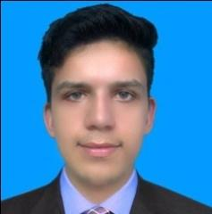
ARSLAN

Email: arslan-392071@2freemail.com

Career Objective

To enhance my knowledge and skills in accordance with organization's
goals and objectives. Leadership qualities with visionary approach and will do approach.

Educational Background

- 2016 ICS Board of Intermediate & Secondary Education Lahore.
- 2013 Metric Board of Intermediate & Secondary Education Lahore.

Professional Experience

- 2 year work experience as a Machine Operator + Cutter Man + Quality Checker in Uni Tax RaiwindRoad Lahore.
- 1year experience Web searching& Data Entry with FALCON RESERCH COMPANY.
  - 1 year experenice as a JUNIOR Operator OVAL MACHINE (PRINTING) IN STYLE CAMPUS RAIWIND ROAD MANGA IS WORK CONTINOUS.

DIPLOMA/COURSE

2 month diploma in web Application Development from University Engineering Technology Lahore.

Languages Skills

- English - Read, write and speaks.
- Urdu - Read, write and speaks fluently.
- Punjabi - Read, and speak fluently.

Extra Skills

- Ms Office ( Ms Word, Ms Excel, Ms PowerPoint, Outlook )
- Using Internet and checking mails etc.
Personal Information

Sex : - Male
Religion : - Islam
Marital Status : - Single
Nationality : - Pakistani
DOB : - 03-DEC-1995

Hobbies

- Cricket , Reading Books & Newspaper , Internet browsing

Declaration:
I hereby declare above mention all information is true as per my knowledge.

