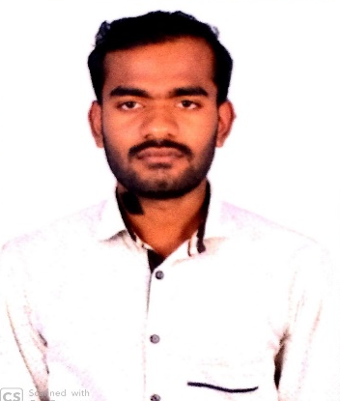
Nabiltheen D.(Mech).,

nabiltheen-392088@2freemail.com

Career Objective:
Experienced production Warehouse Workerbrings a combination of strong leadership skills and the ability to motivate team workers. Has an advanced understanding of workplace safety regulations and ensures that staff is always regulatory compliant. Holds five years of experience and a diploma in mechanical engineering.

Professional Experience:

May 2013 – Dec 2013:Ashok Leyland - Hosur
Worked as Line Quality Controller for LCV (Light Commercial Vehicle)
- Read blueprints and specifications
- Monitor operations to ensure that they meet production standards
- Recommend adjustments to the assembly or production process
- Inspect, test, or measure materials or products being produced
- Measure products with rulers, calliper’s, gauges, or micrometre’s
- Accept or reject finished items
- Remove all products and materials that fail to meet specifications
- Discuss inspection results with those responsible for products
- Report inspection and test data

May 2014 – Aug 2018:BASF Construction Chemicals UAE. LLC – Dubai
Worked as Warehouse Assistant
• Prepares orders by processing requests and supply orders; pulling materials; packing boxes; placing orders in delivery area
• Sort and place materials or items on racks, shelves or in bins according to organizational standards
• Open bales, crates and other containers
• Maintains inventory controls by collecting stock location orders, printing request, recording amounts of materials or items received or distributed through a computer. May also assist in counting of physical inventory
• Prepare parcels for mailing
• Maintains safe and clean work environment by keeping shelves, pallet area, and work stations neat; Sweep, dust and mop. Organize warehouse and work area for orderliness at all times
• Wear the proper safety equipment
Educational Qualifications:
2010 – 2013Diploma in Mechanical Engineering from Sir Issac Newton Polytechnic College, Nagapattinam, India

Technical Knowledge:

- Microsoft Office Suite
- AutoCAD
- Pro-E
- DCA (Diploma in Computer Application)
- GD & T(Geometric dimensioning and tolerance)
- Good Communication Skills
- SAP Programming

Achievements:
- I complete my diploma final year project “Automatic Spray Painting Robot” by 8 days of Internship in Sri Santhasivam Industries in Coimbatore, India in year of 2012.

Personal Traits & Abilities:
- Dedication towards work and quick Learner
- Strong with Ethic Disciplined and good communication & interpersonal skills
- Hard work with Sincerity with Adaptable/Flexible
- Patience and co-operative
- Problem Solving and Decision Making
- Computer/Technology with good leadership and having an Initiative/Analytical

Personal Profile:
Name: Nabiltheen
Date of Birth: 10-11-1994
Nationality: Indian
Religion: Islam
Marital Status: Single
Languages: English, Hindi, Urdu, Tamil, Malayalam
Marital Status: Single

