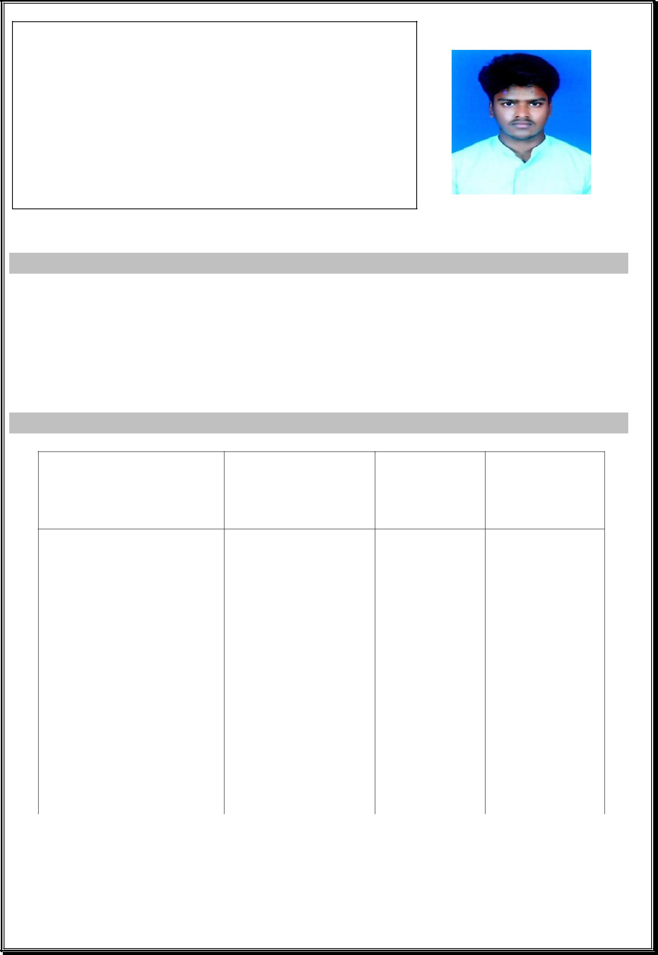
SASIKUMAR

B.E CIVIL ENGINEERING

Sasi-392096@2freemail.com

OBJECTIVE

CAREER OBJECTIVE:

I am a young aspirant waiting for an opportunity.I ensure that I will work with full enthusiasm and make use of the opportunity given to me.The reason that I should be hired for this job is that I can learn quickly and think spontaneously.

EDUCATION QUALIFICATION

COURSE | INSTITUTION | YEAR OF | PERCENTAGE
 |  | PASSING | / CGPA

 | B.E (Civil) | Anna University, | 2018 | 64.5%
 |  | (Bit Campus),
 |  | Trichy.
 |  | Sri Ragavendra
 | HSC | Matric Hr Sec | 2014 | 92.5%
 |  | school,
 |  | Veeraganur.
 |  | Govt Hr Sec
 | SSLC | school, | 2012 | 85.8%
 |  | Ulkottai.
EXPERIENCE :

- Work as a SITE ENGINEER in JKB housing Pvt LTD at Chennai. (From may 2018 to may 2019).

WORKSHOP ATTENDED :

- Participated in a Noval approach in civil engineering workshop at

ANNA UNIVERSITY(BIT CAMPUS) TRICHY.

O

INDUSTRIAL VISIT :

- Participated in intellectual industrial visit at L&T CONSTRUCTION
– Chennai.

INTERPERSONAL SKILLS:

- Ability to think faster and adopt to any conditions.

- As I am the SPL of school ,I can easily mingle with others and work as a team.

- Good communication skills.

EXTRA CURRICULAR ACTIVITIES:

- Very much interested in playing Crickets.

- Intersted in updating about new findings in civil

PROJECTS:

- DESIGN PROJECT - Planning and designing of Beach Resort

- MAIN PROJECT - Experimental study on concrete using M sand and tiles wastages

SOFTWARES KNOWN:

- Autocadd you

- Revit

- Microsoft office

 |  |  | PERSONAL DETAILS
Date of birth |  | : 01-05-1997
Martial status |  | : | single
Nationality |  | : | Indian
Interest &hobbies |  | : | Interest in browsing
Languages known |  | : | English,Tamil
Martial status |  | : | Unmarried

