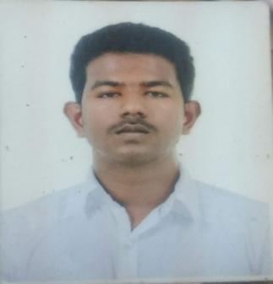

SUNIL
Sunil-392173@2freemail.com

CARRER OBJECTIVES

I seek a job as a Management Administration in a Non Technical part of a Company where I can use my Knowledge and Management Skill. I wish to contribute towards organization goal through my Decision making skill, hard work and creativity.

SUMMARY

- Proficient with MS Office Suite, and business enterprise applications

- Excellent time management, organizational, and communication skills

- Strong attention to detail and problem solving skills

- Self-motivated, honest, and multi-tasking person

- Outstanding networking, researching, and managerial skills

- Experienced in handling office management and public relations

EXPERIENCE

TEAM LEADER (1.3 YEARS)
Hindustan HR Solution

Making the annual budget setting process, performing costing and workforce reconciliations.

Increased business with new clients by creating customized marketing plans based on market data
Conducted training sessions with company employees and clients on use of Outlook to maximize productivity

Improved company's brand awareness by implementing marketing strategies. Assisted in producing monthly and quarterly reports analyzing the prior year and prior latest best estimates.

EDUCATION

Completed my SSLC from Bethlehem Matriculation School in the year 2008
Completed my HSC from Bethlehem Matriculation School in the year 2010

Completed my BBM(Marketing) Degree from Bangalore University in the year 2015
Completed my MBA(Finance) Degree from Bharatiyar University in the year 2019

SKILLS AND ACHIEVEMENTS

During my final year I volunteered as a Student Mentor where I assisted younger pupils with their concerns and gave presentations on topics such as bullying and stress management.

Awarded ‘Employee of the Month’ on three occasions for showing a strong team working spirit.

HOBBY

I have been a member of my university’s Athletic team since 2013 and participated in many marathons.

In June 2015 I took part in the Two Castles run, a 10k run between Melpuram and Marthandam. I raised over 5000INR for a local charity from fundraising and promoted myself by setting up a page which I marketed to my friends and family.

LANGUAGE KNOWN

- TAMIL
- ENGLISH

- KANNADA
- HINDI
- MALAYALAM
- TELUGU

PERSONAL DETAILS

NAME

: M.A. Ayvan Sunil

DATE OF BIRTH

: 10 October 1992

NATIONALITY

: Indian

