CURRICULM VITAE

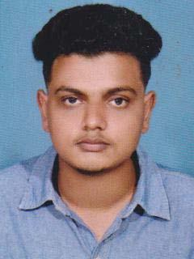

HASHMI

Hashmi-392174@2freemail.com

PROFILE

2 Years Experienced Site supervisor/coordinator seeking a position in an recognized organization to utilize my skill and abilities to the Maximum level. To improve all my strength and employ resources available, and to work to complete perfection, with dedication and professionalism.,

PROFESSIONAL EXPERIENCE:

M/S. EYRIE HOMES

Thrissur, Kerala, India.
Experience: 1+ years
Period: 02.02.2018 to present.
Designation:
* Civil Draftsman /site supervisor.

M/S. TAPIOCA PLANNERS,

Thrissur ,Kerala, India.
Experience: 7 months (part time)
Period: 05.06.2017 – 15.01.2018

Designation:

* Civil Draftsman //site supervisor.

Current Job Description:

- Site supervising & giving instructions to site workers.

- Communication skill with clients.

- Communication skill with suppliers & contractors.

- Preparing the Architectural drawings.

- Knowledge of Architectural detail drawings.

- Knowledge of taking Architectural quantity from cad drawings.

- Ability to Taking measurements from site & preparing drawing

- Well Knowledge of Microsoft Excel & Word

- Well knowledge of preparing the municipality work permit drawing Submission.

QUALIFICATIONS

Educational |  | :Plus-Two (Commerce) – Passed in the year 2017
 |  | (Board of Higher Secondary Examination, Kerala, India)
Technical certificate |  | :Civil Draftsman – Passed in the year 2018
 |  | (Department of technical education, Kerala, India)
Technical Skills |  | :(Auto CAD & 3DS MAX)
 |  | (CAD Center-educational enterprises (P) LTD, Cochin Kerala, India)
Computer Skills |  | :AutoCAD 2010,2013 & 2014
 |  | MS Office (Word, Excel & PowerPoint)
PERSONAL DETAILS
Nationality |  | : | Indian
Marital Status |  | : | Single.
Languages Known |  | : | Hindi & English (Reading & writing only)
Visa Status |  | : | Visiting Visa (Expired on 25th August ,2019)

Personality: Friendly and extroverted; willing to help other and like people. Being systematic and organized, I’m a good team player and self-motivated.

